Dr. John Runciman Ph.D., P.Eng 

Associate Director of Undergraduate Studies

50 Stone Rd E,

Guelph, ON

N1G 2W1

THRN 2408

Dear Dr. Runciman,

Please find attached the interim report “FSAE Rim Design”. This report outlines the progress in the design and fabrication of carbon fibre rims for the Gryphon Racing FSAE team. Should you have any questions regarding this report, please contact us by email at [millero@uoguelph.ca](mailto:millero@uoguelph.ca).

Sincerely,

Nicolas Bessay-Torfs 

Orion Miller

Andrew Roberts

Nicole Smith



**FSAE Rim Design**

Advisor: Dr. John Runciman Ph.D., P.Eng

Group# 26:

Nicolas Bessay-Torfs

Orion Miller

Andrew Roberts

Nicole Smith

February 15th, 2019

*In signing this report and providing my PEO SMP (Student Membership Program) number, I certify that I have been an active member of the team and provided approximately equal contribution to the work. I take shared credit and responsibility for the content of this report. I understand that taking credit for work that is not my own is a form of academic misconduct and will be treated as such.*

**Nicolas Bessay-Torfs**   **054284**

Team Member One Name Team Member One Signature Team Member One SMP#

**Orion Miller 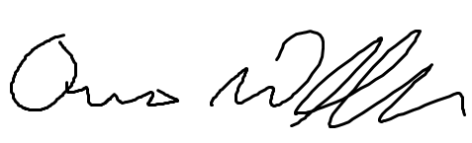 063296**

Team Member Two Name Team Member Two Signature Team Member Two SMP#

**Andrew Roberts**   **059029**

Team Member Three Name Team Member Three Signature Team Member Three SMP#

**Nicole Smith**  **054671**

Team Member Four Name Team Member Four Signature Team Member Four SMP#

# Executive Summary

The goal of this project is to produce a carbon fibre racing rim for the Gryphon FSAE team and to position the team to continue to make carbon rims in the future. This interim report is meant to update the reader on the progress that has been made since the proposal memo stage of the project.

The first section reintroduces the problem description and background which has not changed significantly from the proposal. Performance goals as well as constraints and criteria follow and have been defined in greater detail.

The design of the rim, its structural analysis using ANSYS, the design of the mold, and progress developing the layup process are detailed in Section two. A 2-degree angle was added to the design of the inside shell’s profile in order to ensure release from the mold. A female mold was selected as this would ensure that tire bead geometry is accurate. The final mold design is detailed; it is to be machined in eight parts (four mold parts and four fastening parts) which will assemble to form the complete mold. ANSYS finite element analysis of the designed carbon fibre rim shows that the design’s performance does not deviate significantly from the original aluminum rim. The deflection and strength of the two designs are compared when subjected to four loading cases: maximum acceleration, maximum cornering, road impacts, and over-inflation. The projected weight of the carbon fibre rim is 0.445kg, which would constitute a 73% reduction in weight compared to the original aluminum rim.

The updated work plan is detailed in Section 3. Significant cuts to cost have been made without sacrificing performance; these cuts can be attributed to repairing rather than replacing a damaged vacuum pump and reducing the quantity of resin ordered. Section 3 also outlines some adjustments that have been made to project schedule. Molds are now projected to be completed in the first week of March, with carbon fibre production and testing to follow. This truncates the carbon fibre manufacturing and testing schedule, leading the team to change the final production goal from a complete set of rims to one rim.

**Acknowledgements**

Special thanks to Dr. Runciman Ph.D., P.Eng, Barry Verspagen, Ken Graham, Dave Wright, Gryphon Racing, and Anthony Meola.

Table of Contents

1.0 Introduction 1

1.1 Problem Description 1

1.2 Background Information 2

1.3 Literature Review 6

1.4 Scope and Objectives 7

1.5 Constraints and Criteria 7

2.0 Design Methodology 9

2.1 Rim Design 9

2.2 Mold Design 14

2.3 Carbon Layup Process 18

3.0 Updated Work Plan and Resources 20

3.1 Budget and Schedule 20

3.2 Resources 22

4.0 Conclusions and Recommendations 22

Bill of Materials and Equipment 38

# List of Figures

Figure 1: Suspension geometry of GRC19 8

Figure 2: Example of Positive Camber in Cornering Due to Suspension Compliance 9

Figure 3: Standard Convention for Forces Acting on a Wheel 10

Figure 4: Lateral Forces vs. Slip Angle 11

Figure 5: Maximum Normal Force 11

Figure 6: Traction Circle for 1100N Vertical Force 12

Figure 7: Tire temperatures during Lateral Test 12

Figure 8: Comparison of Finalized Rim Profile (Blue) vs. Aluminum Original (Gray) 15

Figure 9: Thickness (m) of Inner Shell 17

Figure 10: Thickness (m) of Outer Shell 17

Figure 11: The Loading Cases Considered 18

Figure 12: Comparison of aluminum and carbon fibre rims in loading cases 1 and 2 19

Figure 13: Comparison of aluminum and carbon fibre rims in loading cases 3 and 4 19

Figure 14: Isometric Views of Final Mold Design 20

Figure 15: Exploded View of Final Mold Design 21

Figure 16: Mold Assembly Cross Section 22

Figure 17: Mold Assembly Isometric View (Displayed Translucent for Detail) 23

Figure 18: Carbon Fibre Layup Schematic 24

Figure 19: Carbon Fibre Test Piece Using a Safety Hat as a Mold 25

Figure 20: Features to be Machined 25

Figure 21: Updated Gantt Chart 27

Figure 22: New Diagram of Mold with Angles 30

Figure 23: Old Diagram of Mold with Angles 31

Figure 24: Section View of Mold with Pre-machining Material Removal 31

Figure 25: Section View of Mold 32

Figure 26: Hand-Drawn Schematic of Dowels 32

Figure 27: CAD Schematic of Dowels 33

Figure 28: Diagram of Mold Removal Using a Drill Press 33

Figure 29: Diagram of Section Separation 33

Figure 30: Band Saw Cuts to be made in Aluminum Block 34

Figure 31: Preliminary Roughing Tool Path for Section 2 35

Figure 32: Preliminary Finishing Tool Path for Section 2 35

Figure 33: Preliminary Roughing Tool Path for Section 3 35

Figure 34: Preliminary Finishing Tool Path for Section 3 36

Figure 35: Fully Assembled Mold in 3D 37

Figure 36: Fully Assembly Mold in 2D 38

Figure 37: Schematic of Mold Section 1 39

Figure 38: Schematic of Mold Section 2 40

Figure 39: Schematic of Mold Section 3 41

Figure 40: Schematic of Mold Section 4 42

Figure 41: Schematic of Side Handles 43

# List of Acronyms and Terms

FOS – Factor of Safety

SOE – School of Engineering (University of Guelph)

FSAE - Formula Society of Automotive Engineers

GRCxx – Gryphon Race Car (Naming Convention for Gryphon Racing Vehicles)

CNC - Computer Numerical Control

AML – Advanced Manufacturing Laboratory

FEA – Finite Element Analysis

ACP - ANSYS Composite Prep/Post

PVA – Poly Vinyl Alcohol

HSS – High-Speed Steel

BOM – Bill of Materials

## 

## 1.0 Introduction

41XX design projects are completed by all University of Guelph undergraduate engineering students in their final semester. These projects are meant to challenge students with open ended design problems and expose students to the kinds of project planning and management problems that will later be encountered in their careers. Students are required to cap their undergraduate degree by bringing together and applying a wide variety of materials, tools, skills, and techniques learned throughout their studies. The 41XX design project is also an opportunity for students to look forward to the types of careers they wish to pursue. This is an opportunity to gear studies towards fields of interest and learn from working engineers prior to graduation.

This design project focuses on the design, manufacturing, and testing of carbon fibre racing rims. Creating carbon fibre components is a highly specialized, time intensive process that is used in the automotive world to push the limits of performance. When well executed, carbon fibre parts have an unmatched combination of high stiffness and specific strength.

This project has involved the application of skills in finite element analysis and ANSYS, mechanics and MATLAB, manufacturing, and materials science to the problem of producing race-worthy carbon fibre rims. The team has also learned new skills in order to carry out the manufacturing process, including laying-up carbon fibre and vacuum bagging.

## Problem Description

**Impact of Rim Weight on Vehicle Performance**

In a racecar, the performance of the vehicle is limited by the weight of the rims for a number of reasons. Firstly, heavier rims have higher rotational inertia, making them more difficult to accelerate about the spindle axis and steering axis (see Figure below). Secondly, the rims are part of the vehicle’s unsprung mass; higher unsprung mass is harder for the suspension to control. Thirdly, the rims are components of the car that are very far away from the center of gravity. Their weight contributes to the vehicle’s yaw inertia and is therefore very influential on cornering ability.

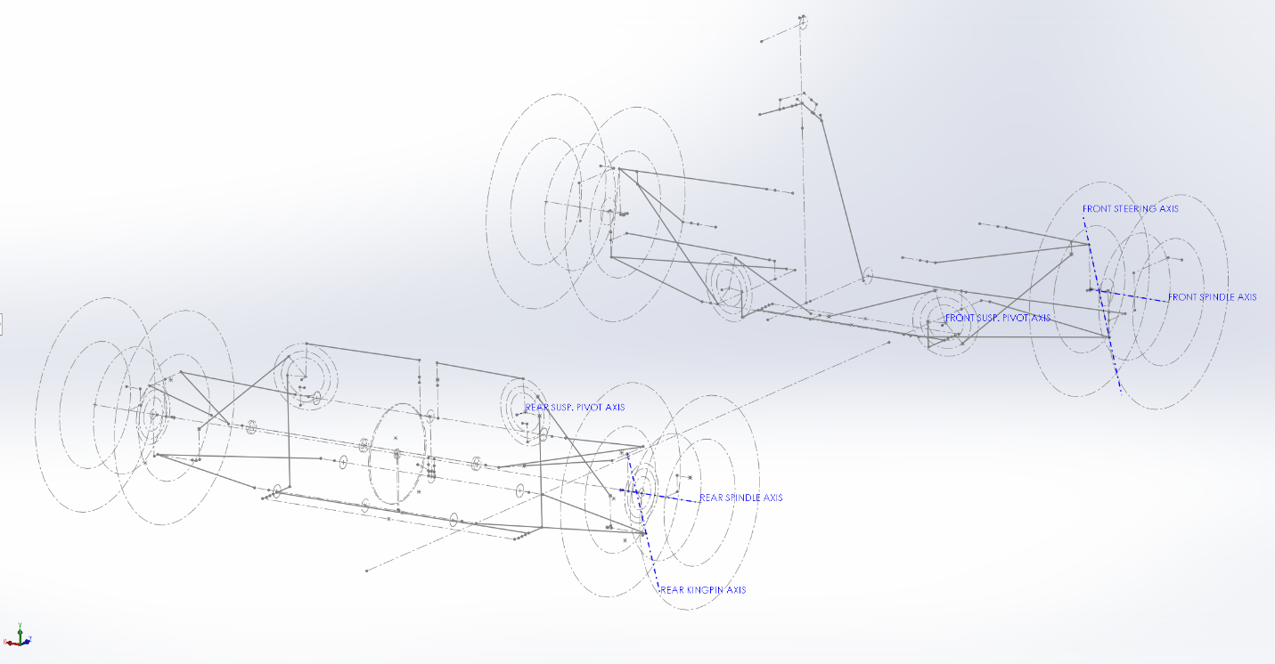

Figure 1: Suspension geometry of GRC19

A major weight reduction would improve these characteristics, as well as causing a significant reduction in total vehicle weight; on GRC18 the rims constitute around eight percent of the car’s total curb weight.

**Impact of Stiffness on Vehicle Performance**

As the part which transfers all forces between the car and the road, the high loading in the rims makes them a major source of suspension compliance. Other sources of compliance include the stiffnesses of the hubs, uprights, a-arms, and frame mounts, as well as free play in all connecting spherical joints, rod ends, and bolts. When designing a car, suspension compliance is to be minimized as it causes the tires to deviate from their intended orientation and range of motion, undermining the suspension’s kinematic properties. One such example of this is positive wheel camber during roll. Positive camber is very detrimental to tire dynamics during cornering; it is often the case that designers set up their kinematics in a manner they believe will make this theoretically possible, yet have it occur once the car is built due to compliance.

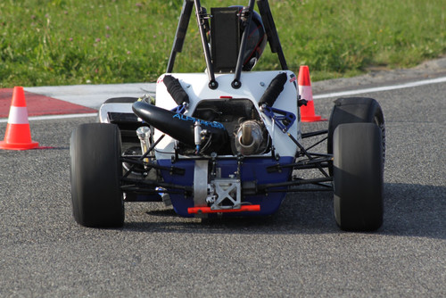

Figure 2: Example of Positive Camber in Cornering Due to Suspension Compliance

Increased rim stiffness can help to reduce compliance in suspension, therefore making the system more predictable and controllable.

**Summary**

Implementation of rims that are both lighter and stiffer would result in major performance improvements to the FSAE car.

## 1.2 Background Information

To determine suitable loading cases on which to base new rim design, suitable loading cases must be determined by investigating the most strenuous situations encountered by the wheels. Vehicle dynamics analysis is required to determine the maximum forces on a wheel in each of the coordinate directions, with consideration for other stresses acting simultaneously due to tire pressure and inertial loading. The rim and wheel assembly will be considered as fixed at the hub mounting surface, with ground reaction loads applied at the geometric center of the contact patch. The coordinate axes defining the forces on a rim are shown below in Figure 3.

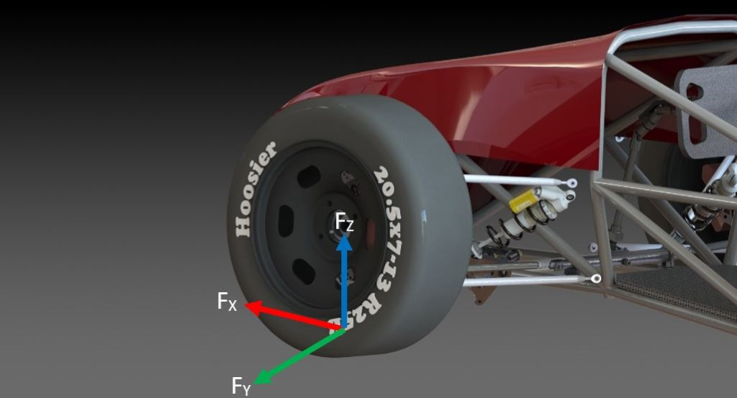

Figure 3: Standard Convention for Forces Acting on a Wheel

**Case 1: Maximum Longitudinal Force Conditions**

Longitudinal forces (X-Direction) are caused by the driving and braking torques. They will put a torsional load on the rim about the center axis of the spindle. This information is typically determined by tire test data, however there is no longitudinal data available for the tires being used as they were only recently released. A reasonable approximation can be made by examining the ratio of maximum longitudinal force to lateral force in the previously used tire’s data and multiplying the maximum lateral force, which is known, by this proportion.

$$F_{X\left(Max.\right)}=1.05F_{Y\left(Max.\right)}$$

$$F_{X\left(Max.\right)}=1.05(2792.0N)$$

$$F_{X\left(Max.\right)}=2903.7 N$$

To be applied in conjunction for this load case are:

* Normal force (Fz) of 1100N: This force represents a longitudinal weight transfer of approximately 80:20 %, which suspension analysis has found to be a reasonable expected amount for maximum longitudinal acceleration.
* Tire pressure force of 101 kPa (14 psi). This pressure represents the maximum upper range of pressure that could be expected for use in an FSAE tire. Note that the maximum longitudinal and lateral forces are taken at 10 psi however, because force is highest at this pressure.
* Inertial loading of 140 km/hr: This is the theoretical top speed experienced by the vehicle during a race.

**Case 2: Maximum Lateral Force Conditions**

Lateral forces (Y-Direction) are caused by cornering forces, and will put a bending load on the rim. Shown below is a plot of lateral force on the selected tires vs. slip angle, a quantification of tire deformation. The plot used is for a value of 10 psi, the lower bound of possible operating pressures, as maximum lateral force is inversely proportional to pressure. The five colors correspond to different values of normal load. The curve of interest is in yellow, which represents 1100 N.

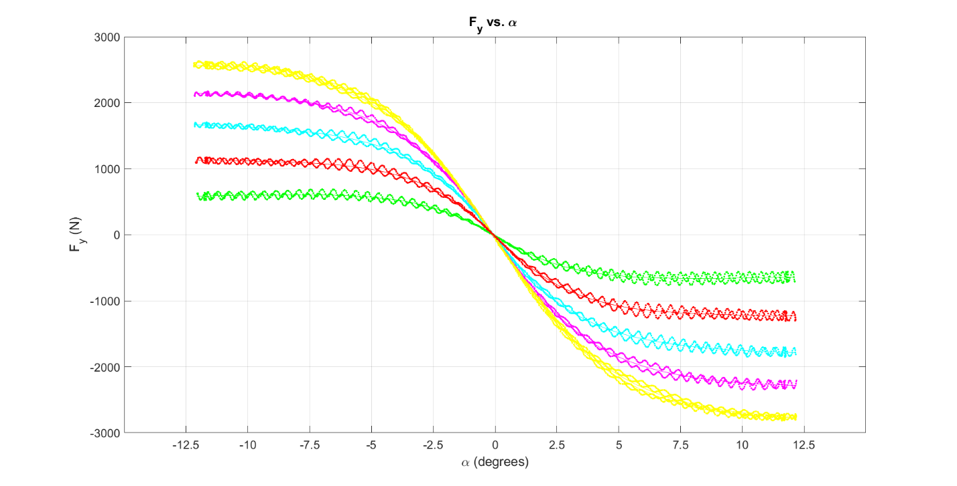

Figure 4: Lateral Forces vs. Slip Angle

From the plot,

$$F_{Y\left(Max.\right)}=2792.0 N$$

Again, 1100 N was selected as the value of normal force, because lateral weight transfer of around 80:20 % is also a realistic upper estimate.The other forces to be applied in conjunction with this lateral force are:

* Normal force (Fz) of 1100N.
* Tire pressure force of 101 kPa (14 psi).
* Inertial loading of 140 km/hr.

**Case 3: Maximum Normal Force Conditions**

Normal forces (Z-Direction) are determined by the weight distribution in the vehicle at a given instant as well as bumps from road irregularities. This force puts a radial load on the tire. Because much of the tire’s stiffness comes from the pressure of the air inside, a large proportion of these loads are transferred to the rim as a uniform compression on the entire outside face of the rim shell. The remainder of the force is transferred to the underside of the rim’s tire bead surface through the tire sidewalls. The proportioning of how these loads are resolved between these two mechanisms is not known; the normal force will therefore be assumed to act 100% through the sidewalls, as the other means (through air pressure) is essentially a hydrostatic stress and is therefore a less severe load.

The maximum normal force is taken to be that applied during a 3g bump to one of the wheels. This is a realistic magnitude to represent a large pothole or bump.

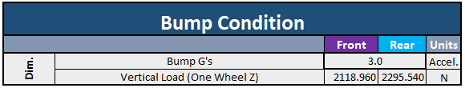

Figure 5: Maximum Normal Force

The difference in front and rear forces is driven by the static weight distribution of the car. Maximum normal force is therefore:

$$F_{Z\left(Max.\right)}=2295.5 N$$

The other forces applied in this case are:

* Tire pressure force of 101 kPa (14 psi).
* Inertial loading of 140 km/hr.

**Case 4: Maximum Inflation Pressure**

The maximum inflation pressure is the last loading case that needs to be considered. No vehicle dynamics analysis is needed for this case as it will simply be determined within the FEA analysis. Maximum inflation pressure is relevant because when mounting tires, the machine applies bursts of pressure to seat the tire bead onto the rim. A maximum psi rating should therefore be determined.

**Sources of Inaccuracy and Limitation**

Although the maximum force situations in each of the coordinate directions are an intuitive way of organizing the design approach, it should be kept in perspective that other force combinations on the tire are possible. Shown below is a traction circle for the selected tires written in Matlab. The ellipse represents the maximum limit of the tire’s traction capacity at different proportions of longitudinal and lateral force. The ellipse is asymmetrical about the abscissa because more acceleration is available in braking than from the two driven wheels. This figure illustrates that there are other combinations of longitudinal and lateral force along the curve which could potentially stress the rim more. However, this traction circle is only an idealized version, real traction circles are less uniformly shaped and require track test data which is not available.

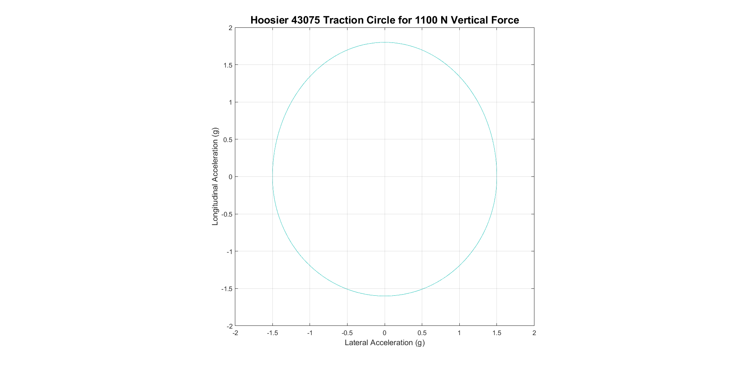

Figure 6: Traction Circle for 1100N Vertical Force

Another source of limitation is how the tire test data used was collected. All forces in the test are essentially “too perfect”, as they are done on very uniform sandpaper-like test belt, with the tire within perfect operating temperatures. Tire test data is supposed to be adjusted with correction factors that are determined from driving test data, so that a more accurate model can be converged upon. This means that forces assumed for longitudinal and lateral force are likely conservative.

Upon implementation of a sufficiently sophisticated range of sensors in the Gryphon Racing vehicles, these loading cases can be revisited and refined.

**Tire Heat Generation**

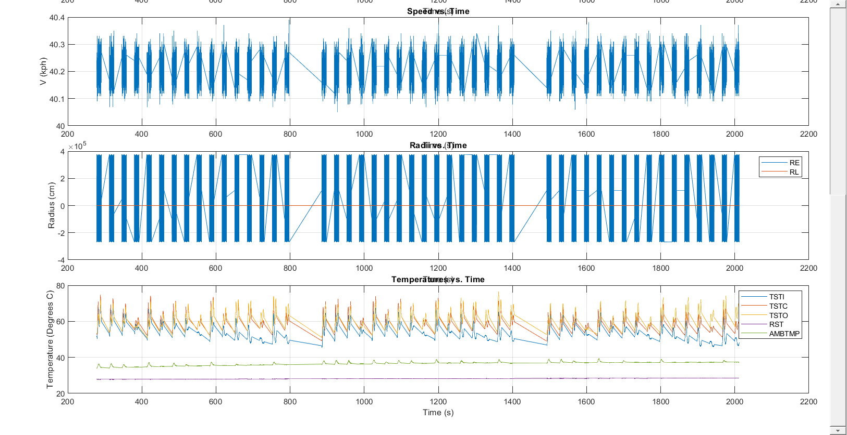

Figure 7: Tire temperatures during Lateral Test

Tire heat generation is now observed to verify to what degree they will heat the rim. This is of interest because the epoxy used for carbon is generally softens at excessive temperatures. Shown above is a plot of the tire temperatures recorded during the lateral test. It is seen that tire tread temperatures reach a range of about 75 degrees Celsius at maximum. This amount of heat generated by the tires is not serious enough to cause issues with the epoxy selected.

## 1.3 Literature Review

Creating components of a car using composite materials is quite common, therefore there is an abundance of online resources that outline important information regarding the design and manufacturing of a carbon fibre part. One such example is “Development of a Composite Wheel Rim for an FSAE Car” by LT Matthew K. Chapman, which went into great detail outlining the layup process [1]. Chapman makes many observations in his report that informed aspects of this project, including the carbon fibre layup process, vacuum bagging, and removing parts from molds. Another resource, “Stress Analysis of Fiber Reinforced Composite Materials” by Michael W. Hyer, helped the team understand how to properly utilize the strength of fibres, how fibre reinforced materials reacted to stresses and deformations, failure theories, and the curing process of composites [2].

## 1.4 Scope and Objectives

The project focuses on the design and fabrication of carbon fibre rims. It began with tire and vehicle analysis to determine suitable loading criteria upon which to base rim design. Force analyses using ANSYS to determine the stiffness of the previous aluminum rims were also completed. An ANSYS analysis of composite carbon fibre rims was performed in order to estimate the number and placement of layers of carbon fibre weave. The final design will attempt to match the stiffness of the original aluminum rims while minimizing the amount of carbon fibre used in order to minimize weight, while maintaining a thickness of the rim less than 1/8”.

To manufacture the molds, a hole will initially be bored into the molds using a 5” end mill. Afterwards, waterjet cutting will be used to remove a large volume of the molds. Lastly, the molds will be machined using the Advanced Manufacturing Lab CNC to ensure accuracy. The mold is made up of four stacked pieces and four additional pieces which will be added to the sides. The four main pieces that make up the mold are designed so that they may be machined separately, fastened together for molding, then disassembled to remove cured parts easily.

Once the molds are completed, prototyping of the carbon fibre rim will be carried out. The rims will be manufactured by hand, laying carbon fibre weave onto the molds and using a vacuum bag to apply pressure and set the laminated layers. They will then be finished (trimmed, cemented, and drilled) and tested to verify that they meet the required stiffness and strength properties.

Throughout the prototyping process small test parts have been and will continue to be made in order to determine the actual physical properties of all parts. ANSYS models of the carbon fibre rims will then be updated using averaged measurements of ultimate tensile strength, density, and layer thickness for the carbon fibre parts. Afterwards, further performance testing with the FSAE car may be performed to ensure proper functioning under racing conditions.

**Performance Targets**

* **Strength:** Because of the possibility that the produced rims will not be as strong as predicted due to manufacturing imperfections or other sources of error, the rims are to be designed to have a minimum factor of safety 30% greater than that of the aluminum rim.
* **Durability:** The rims should have infinite expected life under fatigue analysis.
* **Stiffness:** Stiffness comparable to the original aluminum rims will be considered successful. Stiffness greater than the original aluminum rims while reducing weight would be preferred.
* **Weight:** A weight reduction of more than 10% (while maintaining comparable performance) would be successful, 25% or more would be considered very successful.

## 1.5 Constraints and Criteria

The overall success of this project will be measured by the progress towards establishing and documenting a reliable in-house process for manufacturing carbon fibre rims using the facilities and knowledge available to the Gryphon race team. The project team recognizes that the production of a complete set of suitable racing rims is a lofty goal and may require the efforts of future students to complete the work. For this reason, attention must be paid to documentation and reproducibility of manufacturing methods so that, in the event that total success is not achieved, the project may continue and carbon fibre rims for a future Guelph racing team will still be produced. Therefore, the ultimate goal of this project is to leave future students with the documentation, molds, and tools necessary so that the designs can be refined and carbon fibre rims can be regularly manufactured for the Gryphon race team.

The final carbon fibre rim design is subject to its own constraints and criteria for success, independent of the success of the overall project outlined above. As such, the following constraints and criteria apply only to the final rims produced for Design Day and are not necessarily indicative of the overall success of the project.

**Constraints**

* Adherence to designed dimensions.
* The rim profile must have suitable geometry such that the tire can be mounted.
* The mold must be physically possible to machine. There cannot be any negative angles to mill, and milling cannot be done deeper than the length of the available tooling. Chattering can be encountered when using long tools at high speed.
* The mold must be able to facilitate mold release by some means.
* Geometry of the rim shells cannot be such that they are mechanically locked into the mold after layup.
* The width of the rim must fall within the specified acceptable range (5.5-7.0”) for the selected tires.
* The rim offset must fall within the range of +10 to +30 mm as dictated by vehicle suspension design requirements.
* The rim must use a 12-hole bolt circle of diameter 6.75 inches, with each hole of ¼ inch diameter, for the mounting of the available rim centers.
* The rim must be entirely airtight up to a value of 100 psi.
* There must be some means of tire inflation/deflation incorporated into the rim.
* The rim must be designed such that the tire will not de-bead during operation.
* Inside diameter of the inner rim section must be equal to or greater than 9.35” to accommodate suspension packaging requirements.
* Any machining, sanding, polishing, or other post-processing of the carbon rims should be performed with air extraction available to reduce the risk of adverse health effects which are associated with carbon fibre dust.

**Criteria**

* All mentioned performance targets should be satisfied.
* The carbon weave used should have suitable drapability properties to facilitate proper layup on complex surfaces.
* The directions of the carbon lamina should be oriented proportionately to the applied loads.
* Any machining, sanding, polishing, or other post-processing of the carbon rims should be minimized to reduce the risk of adverse health effects which are associated with carbon fibre dust.
* The molds should be made from material that is available to the group at minimal cost.
* The molds should be designed such that critical tolerances for the rim geometry (critical dimensions and surface finishes) are followed as closely as possible.

# 2.0 Design Methodology

## 2.1 Rim Design

**Material Selection**

The 2x2 twill weave carbon fibre available in the FSAE race shop will be the primary material used to make the rims, due to its ability to easily distort to drape around the rim geometry during the layup process. Using material that is already available allows the cost of the project to be minimized. The epoxy chosen is an Aeropoxy PR 2032 resin which is often used in high performance structural applications of composites. Because the rims will be experiencing forces in varying magnitudes and directions during use, a strong epoxy must be used. The hardener paired with this epoxy is an Aeropoxy PH 3663, which is a common hardener for fabricating carbon fibre parts and has an intermediate working time of 90 minutes. This should be ample time to successfully run through an entire layup process. The peel ply chosen for this project is an Airtech Bleederlease B peel ply. This material is infused with silicon to ensure efficient release from the composite and epoxy. The cotton, vacuum bagging, and other intermediate plastic layers used in the layup process were also found in the FSAE race shop, allowing further reduction of costs.

**Rim Geometry**

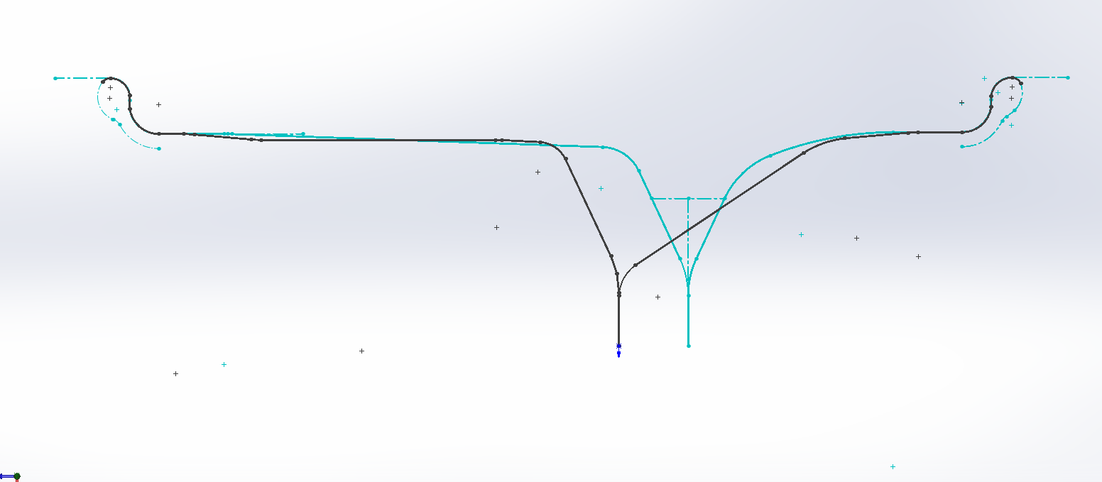

Figure 8: Comparison of Finalized Rim Profile (Blue) vs. Aluminum Original (Gray)

Seen above is a sketch of the finalized carbon rim profile overlain with the original profile of the aluminum rim (Individual sketches available in Appendix Figures 22-23). The inner rim shell is seen on the left, and the outer shell on the right.

The revised rim incorporates a 2-degree draft angle into the inside rim section to facilitate mold release. 0-degree angles are not desirable because this places the part entirely in shear, in which it is strongest. An angle of only 2 degrees is used because of the limitations imposed on minimum rim diameter by suspension design requirements in that section. The revised rim features an increase in rim offset as well, from 12.7 mm to 27.7 mm. This decision was also made for suspension design considerations; the manufactured rims are made available in offsets of discrete 1-inch increments, however a value between two of these was determined as most desirable. This has the beneficial side effect of decreasing the mold’s thickness in the outer rim’s section, decreasing the depth of milling required in the thickest section. The section where the rim curves out from the rim center mount surface has also been made the same for each section, and the curvature in the adjacent area of this curve has been smoothed out.

The rims share the same tire bead geometry. For some rim designs, an additional “hump” is added inward of the tire bead area as an added means of keeping the tire securely seated during operation. In the absence of this feature, the tire bead relies on the friction at the tire-rim interface in combination with the outward air pressure to keep it properly seated. It would not be possible to add a feature like this into the mold because it would not be feasible to machine with a 3-axis vertical mill and it would also result in the rim being mechanically locked into the mold after layup. Extra thin strips of carbon could in theory be added on after the main layup process, when the part has been removed from the mold. However, this feature is not commonly used so it is assumed to be unnecessary to keep the tire properly seated. If issues are encountered with tire de-beading, this idea will be revisited in the future as modifications of this nature can be easily made.

**Structural Analysis**

The current car rims are aluminum and 10 inches in diameter; to begin, a solid model of these rims was downloaded from the supplier and uploaded into ANSYS for finite element analysis. Four loading cases were considered: cornering, accelerating, road impacts (pot holes or bumps), and over-pressurized tires. This analysis produced estimations for the locations of deflections on the rim and their magnitudes. These deflections were then used to design the carbon fibre rim.

After the design of the mold and the profile of the carbon fibre rim was finalized, further finite element analysis was conducted using the ANSYS composites package (ACP-pre) to model a carbon fibre rim. A shell of the mold geometry was uploaded to ANSYS and the rim was separated into an inner and outer hemisphere that would be modelled separately (joined later for the structural analysis). The faces that carbon mats would be laid-up onto were added to “named selections”; these locations included two rings to reinforce where the profile of the rim changes quickly. The number of layers, the location of reinforcements, and the orientation of the layers were changed to see how this affected the stiffness of the rim and how this compared to the aluminum rim.

The current carbon fibre rim design calls for 6 main layers of woven carbon mats, with 6 reinforcing layers to be added between the main layers for a total of 12 layers in the reinforced areas. The resulting profiles can be seen in figures 9 and 10 below.

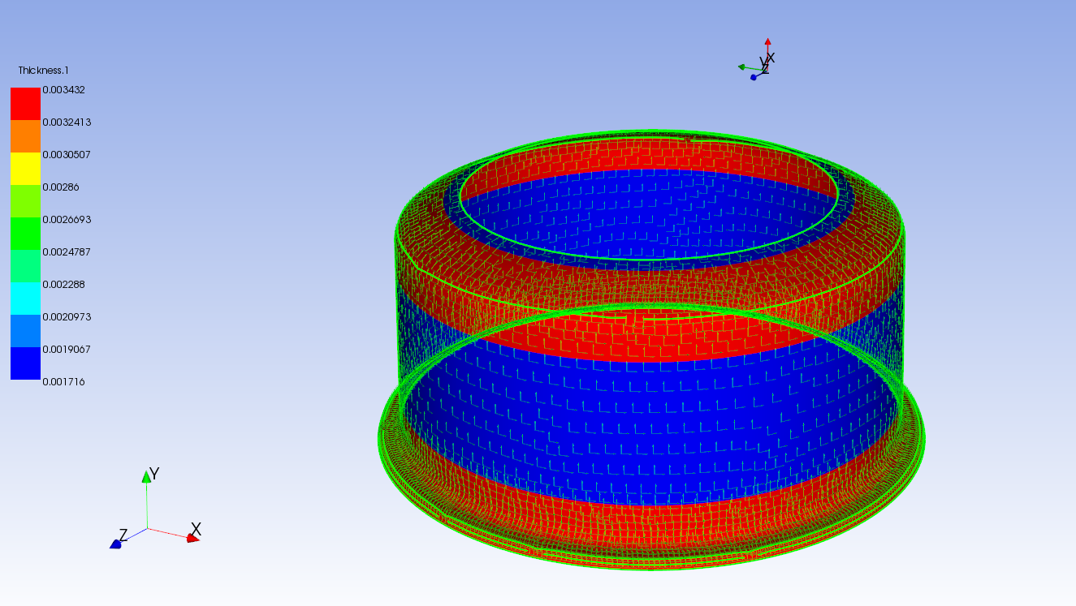

Figure 9: Thickness (m) of Inner Shell

The 1/8” thickness of the original aluminum rim constrains one aspect of the carbon fibre design; in both designs, the thickness at the point where the rim contacts the tire (the tire bead) must be the same. It is necessary that this area be the edge of the laminated carbon mats, and common practice is to reinforce this area as it has the highest risk of fraying. When designing the rim, it holds that although the outer edge requires reinforcement, it should not vary significantly from the thickness of the original rim of 1/8”. In the design this is satisfied; for each hemisphere shown the thickness at the outer edge is 3.2mm which is only 2% more than 1/8” (3.175mm).

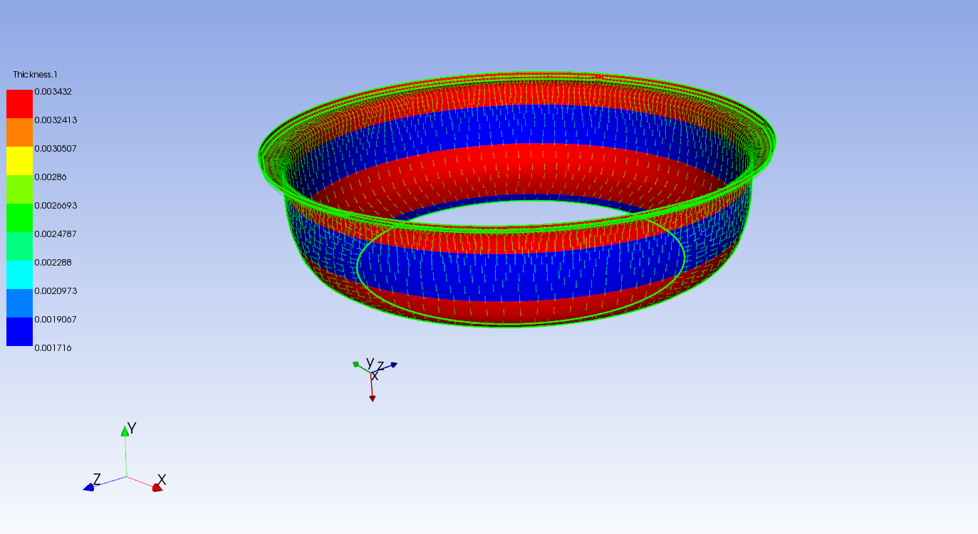

Figure 10: Thickness (m) of Outer Shell

The loads and fixtures used are shown below in Figure 11. The numbers in these figures correspond to the following loading cases: 1 – over-inflation, 2 – maximum longitudinal force, 3 – maximum lateral force, 4 - maximum normal force.

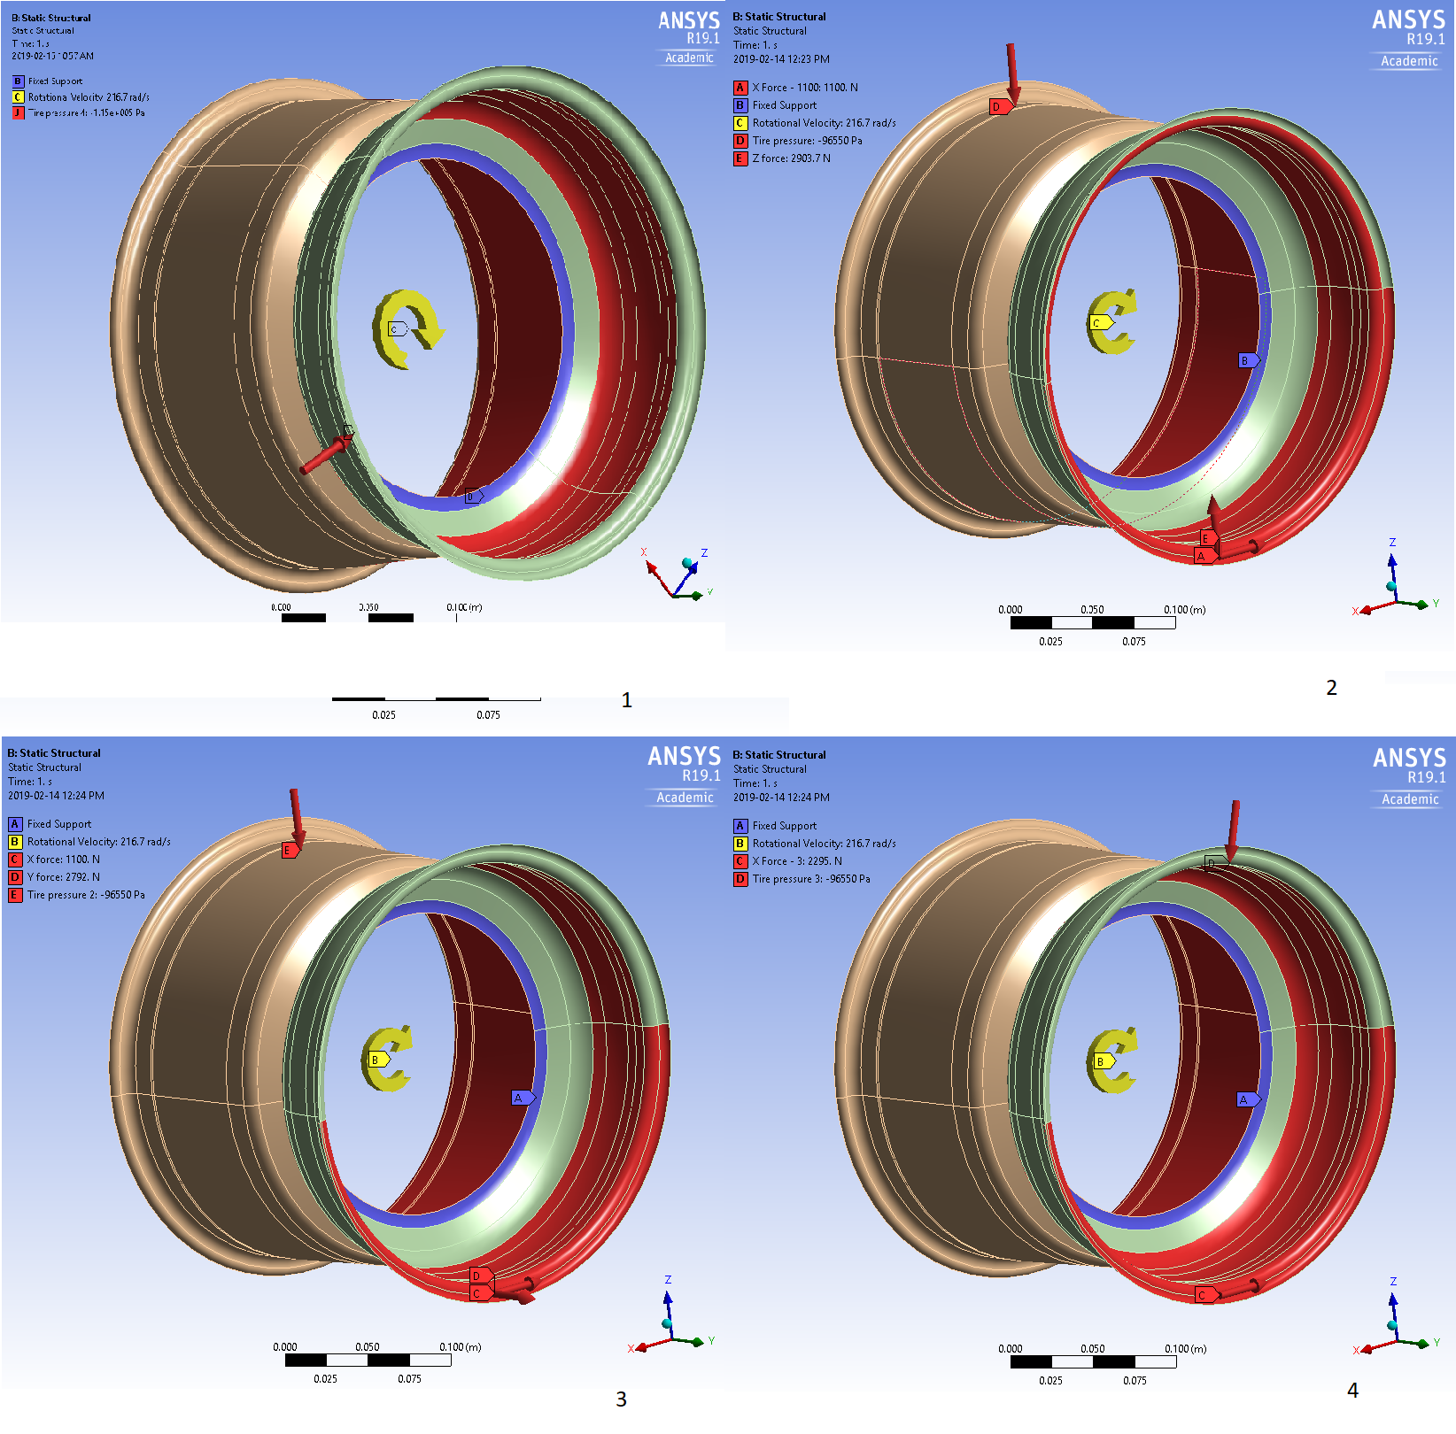

Figure 11: The Loading Cases Considered

The carbon fibre rim performs comparably to the aluminum rim in each of the simulated loading cases. Figures 12 and 13 below show the stress and deflection of the aluminum rim alongside those of the carbon fibre rim.

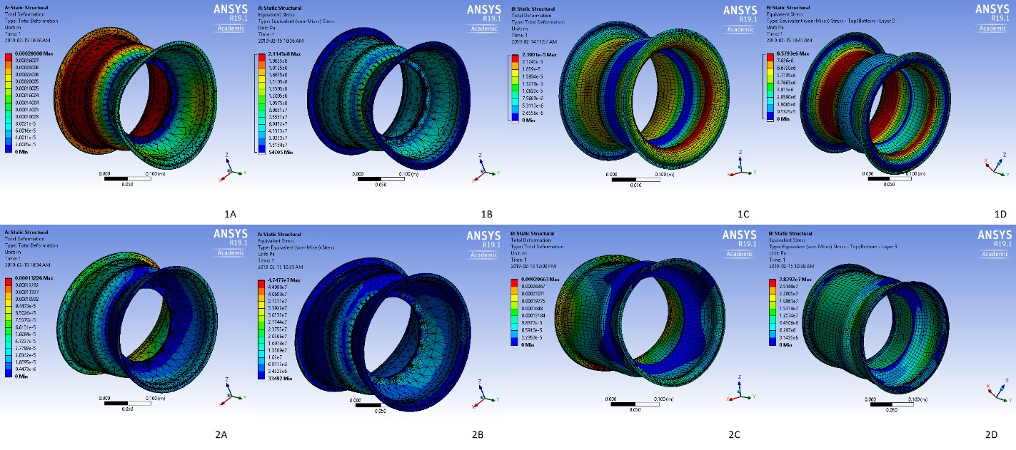

Figure 12: Comparison of Aluminum and Carbon Fibre Rims in Loading Cases 1 and 2

A and B are the deflection and stress respectively of the aluminum rims, C and D are the deflection and stress respectively of the carbon fibre rims.

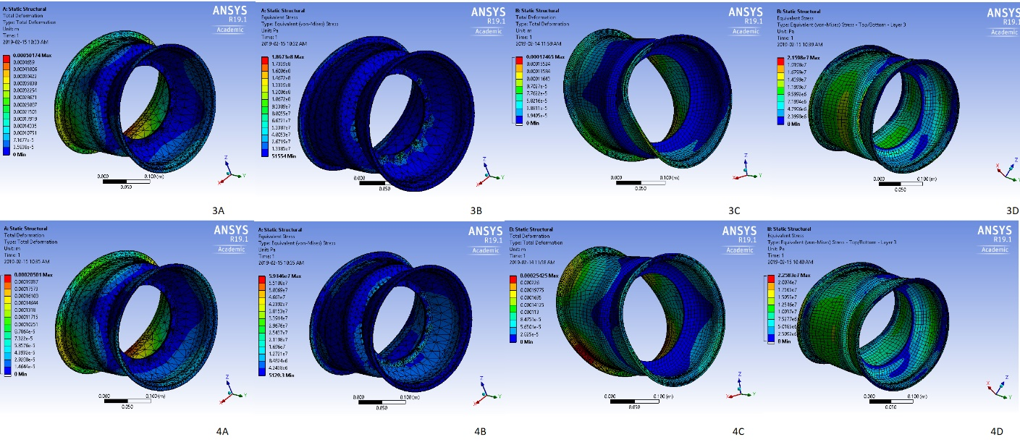

Figure 13: Comparison of Aluminum and Carbon Fibre Rims in Loading Cases 3 and 4

A and B are the deflection and stress respectively of the aluminum rims, C and D are the deflection and stress respectively of the carbon fibre rims.

The mass of the carbon fibre rims can be estimated using the properties of the geometry found in ANSYS; the volume in ANSYS is 1.911e-4 m^2 and the surface area is 0.0955 m^2. The mass of the carbon fibre is then its mass per cubic metre (200 g/m^2) multiplied by the surface area, multiplied by the number of layers. The mass of resin used will be 1.15 g/cc multiplied by the volume of the part. The total mass is then 0.230kg of carbon plus 0.219kg resin for a total mass of 0.445 kg. Since the aluminum rim has a mass of 2 kg, the carbon fibre rim is projected to be 73% lighter. With four rims the total weight reduced from the car would be 6.22kg.

## 2.2 Mold Design

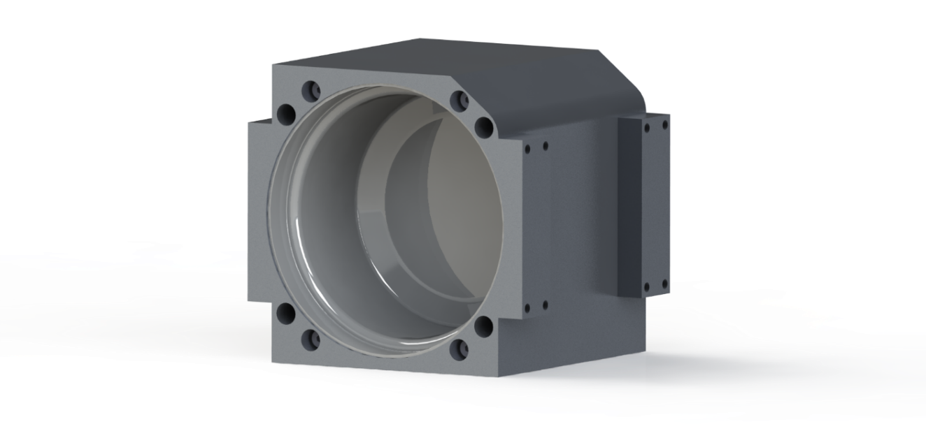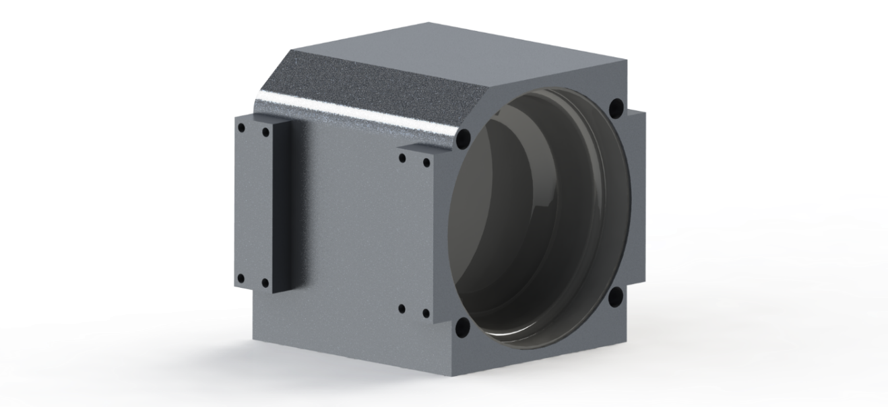

Figure 14: Isometric Views of Final Mold Design

**Type of Mold**

A major decision to be made is whether to use an internal or external mold for the rims. A male mold would be made on a lathe or mill and would use the least amount of stock material. It also allows the possibility of mounting the assembly on a spindle to be rotated during the layup process. A female mold would require more material and would be made in a mill. It would require more vacuum bagging as the material must curve around and into the cavity.

A key consideration in this decision is which surfaces of the rim geometry are most important. The surface lain up on will be perfectly accurate to the mold and have superior surface finish. From this perspective, a female mold has a noticeable advantage. The tire bead geometry is of critical importance as there are tightly defined requirements for the rim-tire interface. Additionally, the rest of the outer rim surface must have a smooth surface finish so that seating the tires will be feasible. Lastly, the surfaces where the inner and outer shells attach to each other (the rim center mounting feature) should be as smooth and flat as possible; this surface would also be covered with a female mold.

For these reasons, a female mold is best suited to meet the design requirements. The mold will be created out of 4.5” 6061-T6 aluminum slabs that are available to the group through the Gryphon Racing team. Aluminum is an ideal material for this detailed section due to its machinability. Also, as a high-density material, aluminum does not require any gel coat on the mold surface.

**Sectioning**

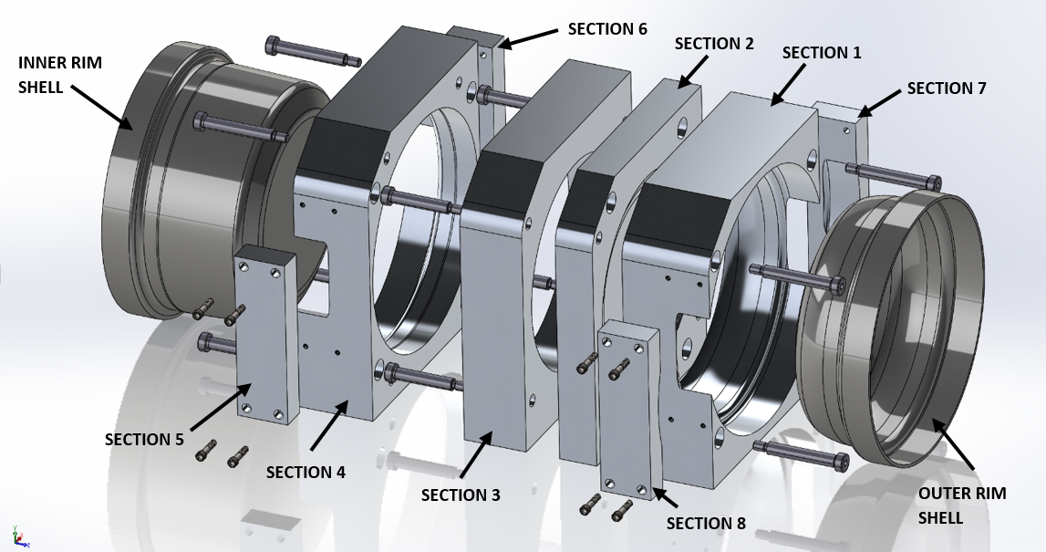

Figure 15: Exploded View of Final Mold Design

The mold will consist of 8 aluminum blocks in total, with four major sections. The outer rim shell geometry is contained within Sections 1, 2, 7, and 8. The inner rim geometry is contained within sections 2, 3, 4, 5, and 6. Sections 5-8 are small blocks added on to the edge of the inner and outer rims because the available material is slightly too small to incorporate the geometry entirely. The major sections are also rounded in one of the corners because of the shape of the available material (Appendix Figure 30). Note that only one rim shell will be created at a time, working exclusively with an assembly of their associated blocks. The designs are only shown as a full assembly as a convenient means of displaying all parts to be used. This would also be a convenient configuration for storage.

Section 2 is designed to be reversible so that it may be used for both laying up and drilling for either of the two rim shells. The sides used for laying up and drilling will be kept consistent such that one side is marked up from being used for all machining operations whereas the other is always used for layup and remains clean.

The edges of both the inner and outer rim shell geometry feature a continuation of the mold at the tire bead diameter. For carbon layup, it is good practice to create a bigger part than required because the edges often have issues with fraying and not saturating entirely. An additional 35 mm of length is provided so that this material may be trimmed away as excess.

With the goal of minimizing the number of sections required, mold development began from a version using three major sections (Appendix Figure 24). However, it was decided that it would be better to use four so that three of the sections would feature a “through hole” which could be waterjet cut out to expedite material removal and the fourth section would allow for the previously mentioned functionality of Section 2. The design was then changed to include a fourth section as a flat plate to incorporate these considerations. As the details of this configuration were further evaluated, concerns arose with this design as well. The flat plate connected with Section 1 caused a knife edge geometry in that section. This is not desirable because this feature could break, would be very sharp, and may not machine accurately. Also, in Section 1, the thickness of the part was very close to the upper limit of what depth can be machined. To resolve these issues, it was determined that it would be more appropriate to place the seams on either side of Section 2 as slightly inward on the rim curvatures rather than at their mounting surfaces. A cross sectional view of the final sectioning layout is shown below.

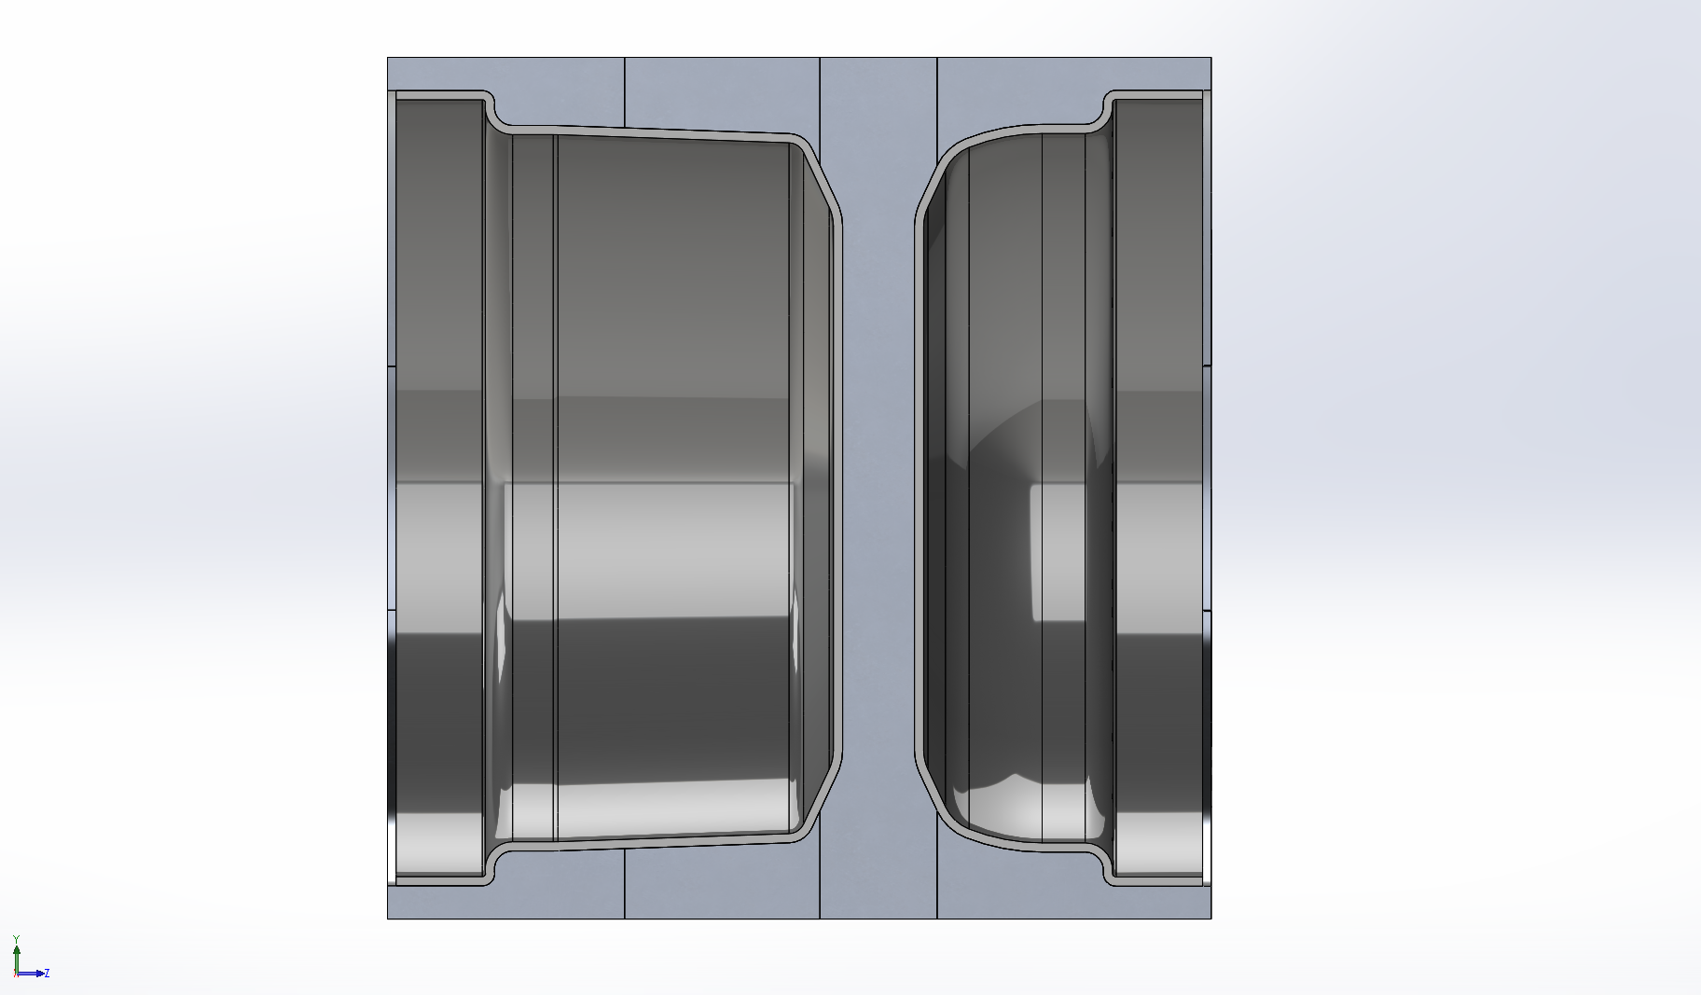

Figure 16: Mold Assembly Cross Section

**Fastening and Mold Release**

The sections will be attached and unattached using a combination of socket head shoulder bolts and standard socket head bolts. Shoulder bolts are desirable because they allow the part to be both properly located and attached with one piece of hardware. A previous design consideration was to use standard bolts in combination with dowel pins to ensure proper location, however this adds additional room for error in the manufacturing process as it requires each section to be flipped (Appendix Figures 26-27). Using shoulder bolts allows the same functionality to be accomplished with less complexity.

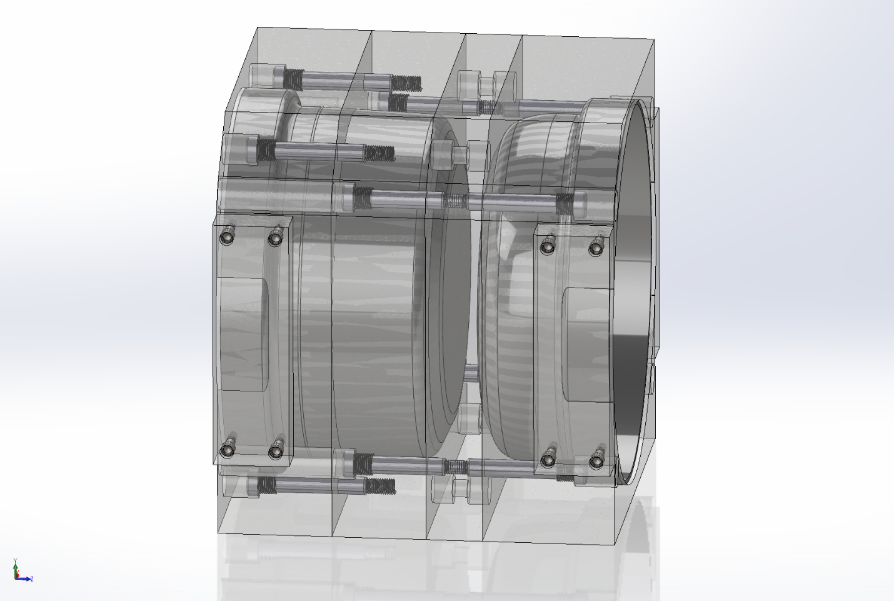

Figure 17: Mold Assembly Isometric View (Displayed Translucent for Detail)

Mold release is intended to be accomplished by separating the major sections and pressing the finished rim out using a hydraulic press (Appendix Figure 28). For the inner rim shell, this will mean removing Section 2, then Section 3, afterwards pressing the part out of Section 4 from above. For the outer rim shell, Section 2 will be removed before pressing the part out of Section 1.

Preliminary design explored the option of machining slit features between each of the major sections, such that wedge-shaped objects could be driven in to separate the parts (Appendix Figure 29). However, because the rims have a large amount of surface area and may require significant force to remove, even with proper application of PVA mold release, the group was not confident in the effectiveness of this method. These design features were removed in favor of another strategy; bolts are to be threaded in to the existing fastener holes to drive the sections apart (Appendix Figure 26,27). Standard 5/8” bolts can be adapted for this purpose by making some simple step-down modifications in diameter along their length.

**Manufacturing Procedure**

The planned manufacturing process of the molds are outlined below (drawings and CNC toolpaths available in Appendix Figures 31-41):

1. Bandsaw cutting of aluminum blocks for Section 1-8.
2. Manual milling of blocks to square them to the correct length, width, and height.
3. Drilling/boring of fastener holes using manual mill.
4. Tapping of required ¼”, 3/8”, and 5/8” threads.
5. Waterjet cutting of Sections 1,3, and 4 to remove material for rim geometry.
6. CNC machining of Section 2, side 1.
7. CNC machining of Section 3, by attaching to Section 2.
8. CNC machining of Section 4, by attaching to Section 3.
9. CNC machining of Section 2, side 2.
10. CNC machining of Section 4, by attaching to Section 2.
11. Sanding and polishing of rim surfaces.
12. Machining of mold release bolts on manual lathe.

For the machining of the sections for each rim shell, it is important that the CNC machining is done sequentially with each block to be bolted on top of the other in the machine. This allows the same original datum from zeroing on Section 2 to be maintained so that each profile is machined entirely with respect to it. If each piece were to be machined separately, there would be an increased likelihood that the seams at the profile would not match up perfectly when sections are joined because of small errors re-zeroing the parts.

## 2.3 Carbon Layup Process

**Layup procedure**

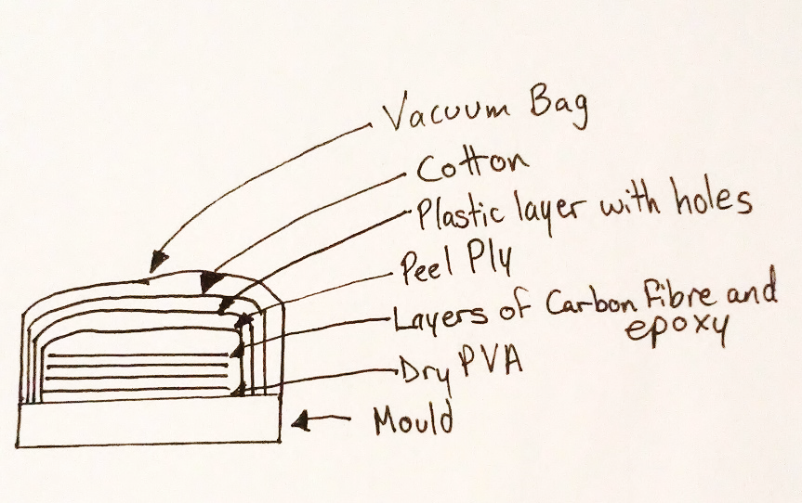

Figure 18: Carbon Fibre Layup Schematic

As seen in the diagram, the first step in a layup procedure is the mold. The surface of the mold which the composite will be laid up on first needs to be degreased with isopropyl alcohol and have a layer of PVA mold release applied. The PVA should be applied using a brush or cloth. After the PVA has dried for at least 15 minutes, a thin layer of epoxy is applied to the surface and the first layer of carbon fibre is laid down. After the carbon fibre is secure, a layer of epoxy is applied using a dabbing motion to the carbon fibre. This process is repeated until the number of composite layers required is achieved. Peel ply is set on top of the carbon fibre-epoxy stack. This layer of peel ply has many uses such as slight absorption and dispersion of epoxy and allowing release after curing. After this step comes the layer involving a plastic sheet with fine holes. These holes allow the epoxy to disperse when the vacuum is turned on. When the epoxy is dispersed, it gets absorbed by the cotton layer. This cotton layer prevents any extra epoxy from pooling in one area of the piece. The last layer is the vacuum bag, which is secured to the mold using double sided tape. This bag has a small hole cut into the top of it to insert the valve into the system. Pleats must be created in the vacuum bag to allow for sufficient suction in highly curved regions of the mold.

To practice this detailed process, test pieces were made using a different carbon fibre found in the race shop. Using a safety hat as a mold, the layup process was completed. The hat was made using only two layers of carbon fibre and could withstand a large amount of force. Four pleats were cut into the pieces of carbon fibre to allow proper draping of the composite. The same method must be used when creating the carbon fibre pieces of the rim. Additional strips of carbon fibre will be used to create an appropriately sized tire bead for the rim. These extra layers will also ensure the bead will not fail when in use. At the edge of the tire bead, the layers will end slightly below the edge of the mold surface so that the vacuum bag will not catch the carbon and peel it downward off the mold.

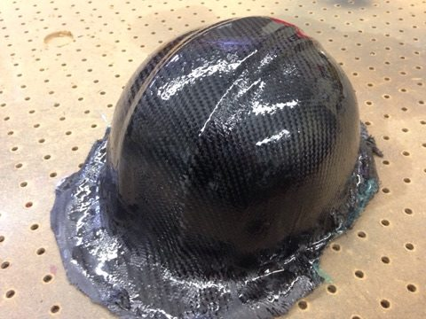

Figure 19: Carbon Fibre Test Piece Using a Safety Hat as a Mold

**Post-Machining and Finishing**

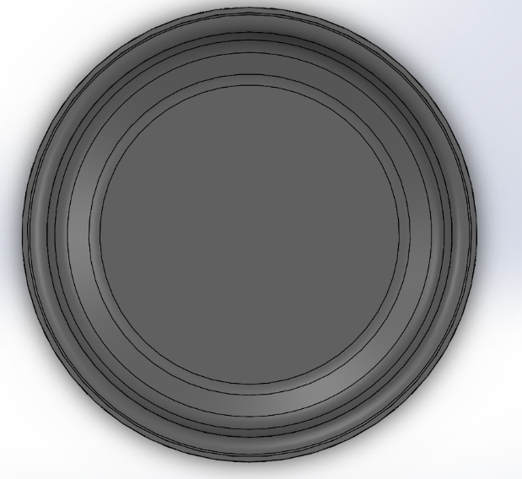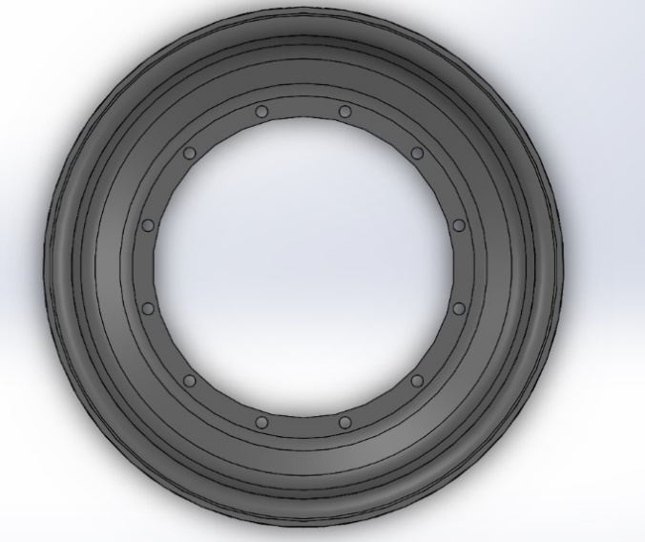

Figure 20: Features to be Machined

There are some precautions necessary for the machining of carbon fibre in terms of both safety and the quality of the machining. Machining carbon produces fine particulates that are hazardous to breathe in, therefore it must be done with the use of either an extraction system or dust binding coolant. This means that the machining facilities available in the School of Engineering are not suitable. The team plans to make use of Gryphon Racing’s CNC router and extraction system to carry out all carbon machining.

Special care must be also taken during this process because of carbon’s abrasiveness and sensitivity to machining conditions. In industry, typically diamond coated carbide tooling is used because high speed steel (HSS) or uncoated carbide will wear at an accelerated rate. Wear will be further increased if the feeds and speeds are either too high or low. For drilling, standard 118-degree angle drill bits are known to cause delamination of the lamina when making holes. Drill bits with elliptical profiles and other specialized geometry can be used to avoid delamination because they apply less downward pressure in the drilling process. [3]

The team has chosen not to make the extra investment into this tooling as it was determined to be cost prohibitive. Also, although this equipment is most suitable, regardless it can still be quickly ruined when used incorrectly by inexperienced operators. Therefore, milling of the center bore will be done with a common HSS router bit. Drilling of the 12 bolt holes can be done successfully by sharpening a standard drill bit to a 60-degree angle. An additional hole for the pressure valve will be drilled by hand in a location that remains to be determined.

With machining completed, the parts will then be finished by lightly sanding with fine sandpaper, applying a gloss clear coat to improve the appearance of visible surfaces, and sealing them together.

## 3.0 Updated Work Plan and Resources

## 3.1 Budget and Schedule NEEDS UPDATE

**Budget**

Mold constraints have led to a significantly increased number of fasteners. This will have a small impact on the budget, but the significance of these costs should be absorbed by the much larger costs of materials.

Since commencing the project, the budget has been followed without incident and in some cases, opportunities for significant cost reductions have been found. Initially it was believed that a new vacuum pump would have to be purchased. By repairing the old one, this cost was mitigated. Epoxy costs have also been decreased as early estimates for necessary amounts were found to be exaggerated.

Although costs have been cut in some areas, it has been decided that much time can be saved by having the plates for the mold water cut instead of machining them. This may push the project over budget but should be offset by the significant savings that have been found.

The application for lab fund has been approved, and funding should be provided within 2-3 days. This funding will be sufficient to cover the majority of project costs and once it is acquired, purchase orders for all remaining materials can be made.

From a budgetary perspective, this project is well on its way to successful completion.

**Schedule**

At this time, all planned milestones have been met. Some portions of this project have taken longer than expected, but due to the flexible nature of the schedule, time was recovered by performing some tasks concurrently rather than consecutively.

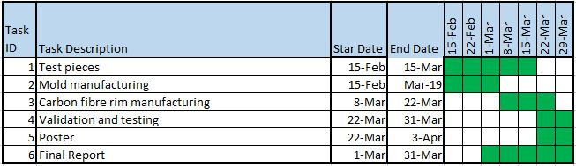

Figure 21: Updated Gantt Chart

An updated Gantt chart detailing the team’s schedule is shown above. Although tasks have been performed in a timely manner, there may be some deadlines set during the proposal stage that will not be met. Mold manufacturing, rim manufacturing, and testing may not be completed in February due to longer machining times and delayed acquisition of materials. Unfortunately, this portion of the project must be completed consecutively and therefore past time-management strategies will not be feasible. As a result, subsequent production and testing will need to be done in less time than originally planned. Although this setback was unforeseen, later stages of this project were planned with exaggerated times to be used for other tasks if the need arose. The limited time also means that only one rim will be produced, rather than four as initially planned.

1. The resources still required include: tools and space to works safely with carbon fibre, a shop capable of water cutting large aluminum plates, access to large amounts of time in the machine shop, and the acquisition of the raw materials to be purchased with the lab fund. The tools needed to work with carbon fibre will be borrowed from the race team. Due to the nature of carbon fibre, the main difficulty has been finding a space where the team can work freely on the rims once they are made. Cutting of this material results in the release of potentially hazardous fibres of carbon into the air. For this reason, it has been decided that in order to use the race team shop, an extraction system or dust binding coolant will be needed to dispose of the airborne carbon fibre filaments.
2. Some challenges that are anticipated in the near future are related to the molding of carbon fibre parts. Working with carbon fibre is very difficult and there are several potential errors that could compromise the quality (and therefore the performance) of the rims or even the molds themselves. Poor installation could lead to poor appearance, performance of the rims, or the inability to separate part from mold, which would mean the destruction of all physical products of this project. In order to minimize these risks and familiarize group members with the intricacies of composite molding, several test parts have been made. Using knowledge gained from these trials, more test pieces will be made with specific attention on the details that have given the team difficulty in previous trials.
3. Several challenges were already encountered which had to be overcome in order to progress in this project. One such issue was the early misconception that the provided aluminum plates were large enough to make the mold. While this proved to be false, some modifications to the mold and alterations to the planned machining process quickly solved this issue. Another problem discovered was the rigidity of the carbon fibre sheets that were in the FSAE shop. During testing, the team discovered that sheets of this rigidity would not be able to cover the particular geometry of a rim. Far more flexible sheeting was found, which may be more difficult to cut cleanly, but will easily forms to the curves of the design. Some of the early test pieces have proven to be unsuccessful, but recently a hard hat was molded with a fair degree of strength and dimensional accuracy. Before an attempt to make rims is made, the team will continue learn as much as possible about the carbon fibre manufacturing process through trial and error with simpler geometries. This way, many problems relating to material properties can be solved so that the team can focus efforts on meeting geometry related difficulties when that stage of production begins.

## 3.2 Resources

**People**

Barry Verspagen – SOE Mechanical Technologist: Assists group in coordinating CNC machining in the AML.

Ken Graham – SOE Machinist: Provides general machining advice.

Dave Wright – SOE Machinist: Provides general machining advice.

Anthony Meola – Gryphon Racing Design Lead: Consults with group to assist in planning of carbon layup process.

**Reference Documentation and Literature**

See references.

**Software**

MATLAB – Used for building tire data processing programs.

SOLIDWORKS – Used for solid modeling of rims and mold assembly.

ANSYS – Used for performing FEA of Aluminum and Carbon Rims.

MasterCAM – Used for programming CNC toolpaths.

Microsoft Word + Excel – Used for preparing documentation.

**Equipment and Materials**

See Appendix for complete BOM.

## 4.0 Conclusions and Recommendations

This project focuses on the design, manufacturing, and testing of composite rims. The overall weight of the car will be reduced while the overall performance will be improved. The entire process of manufacturing carbon fibre rims will be documented to allow the members of the Gryphon race team to have easy access to this knowledge.

Significant changes have been made to the project since the creation of the proposal memo stage. These include the use of water cutting alongside CNC machining (to eliminate a higher volume of material at a faster rate), and the change from a two-piece to an eight-piece mold in order to accommodate the tooling available at the University of Guelph. Lastly, the project team will allow the race team to have possession of any completed rims, however, the ownership of the intellectual property (in the form of a detailed document) will belong to the project team.

**5. References**

[1] Chapman, Matthew K. “Development of a Composite Wheel Rim for an FSAE Car”. University of New South Wales. 2011. Print.

[2] Hyer, Michael. “Stress Analysis of Fiber Reinforced Composite Materials”. Boston: McGraw-Hill. 1998. Print.

[3] MacArthur, Mike. “How to Machine Carbon Fibre and Today’s Difficult Composites”. Youtube. Feb 10, 2012. URL: https://www.youtube.com/watch?v=OIaL_epxjoA.

**Appendices**

**a. Response to feedback**

Feedback to the previously submitted proposal and respective responses:

* “Formatting needs to be improved”- signature pages, acronyms, and appendices have since been added to the report to enable easier reading.
* “Identify what the design/project goals are and write report according to those goals” – specific goals have been selected and each section of the report is used to support these goals.
* “Detail to scientific wording when necessary (i.e. forces are expressed in magnitudes and direction)” - extra care has since been added to ensure every detail that is necessary has been provided.
* “Consistent level of writing” - extensive editing has been completed on the report to make sure it reads well.
* “Ownership should be the project team’s, not the race team’s” - while the finished carbon fibre rims will belong to the race team, the project team will now take ownership of the process and information acquired during the project.
* “Constraints and criteria are weak” - this section has since been reviewed and modified to incorporate more detail especially regarding the design of the molds.
* “Addition of a conclusion section” - a conclusion has been added to properly compete the report.

**b. Calculations/modeling required for evaluating design alternatives**

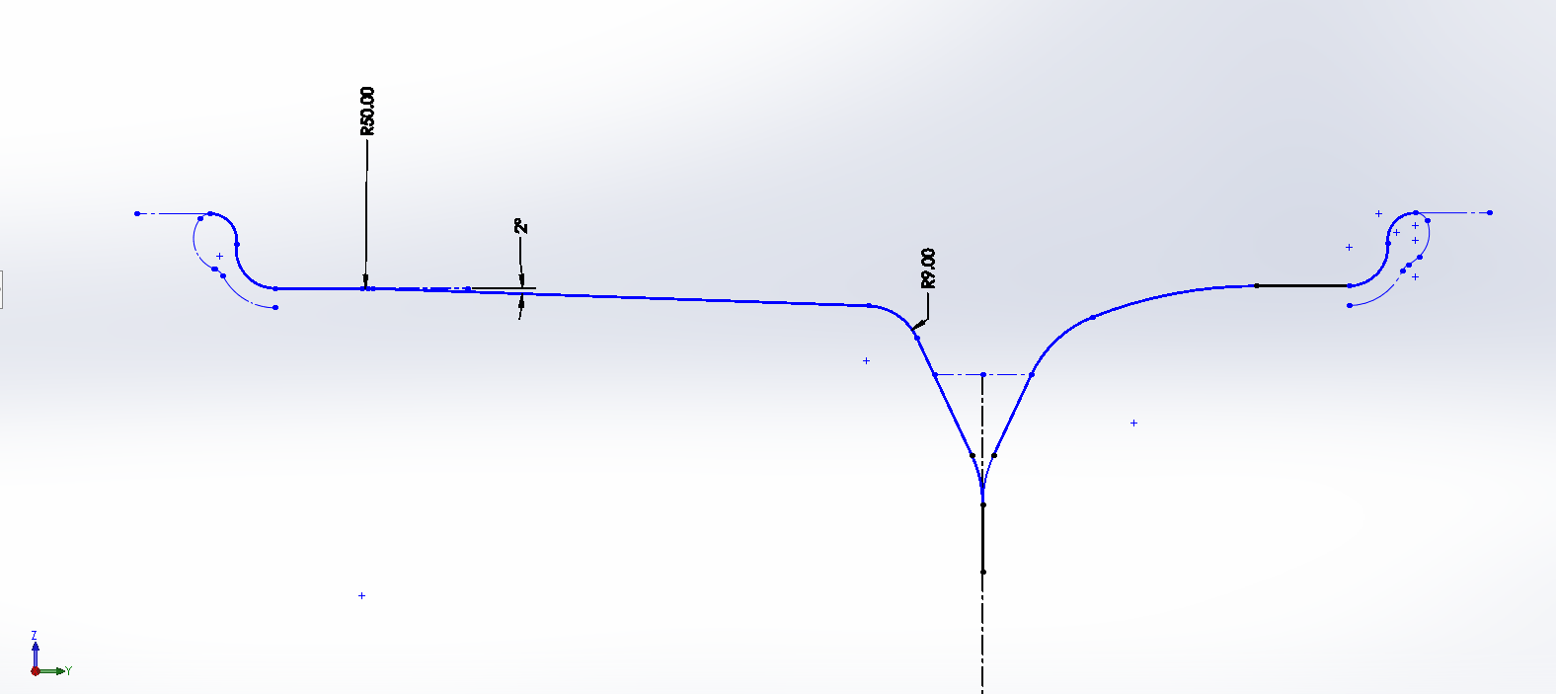

Figure 22: New Diagram of Mold with Angles

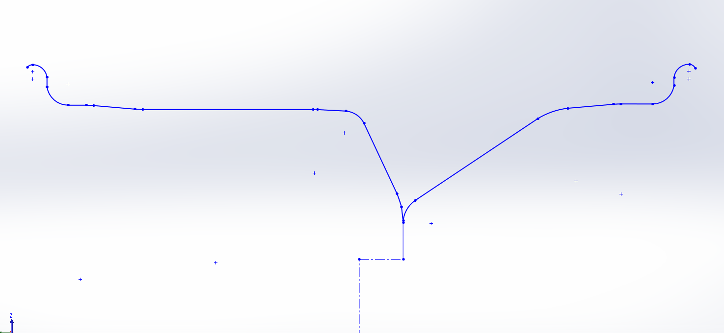

Figure 23: Old Diagram of Mold with Angles

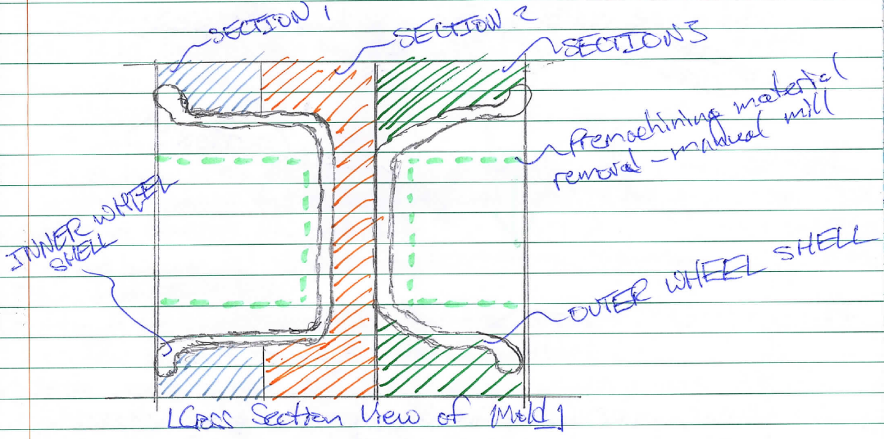

Figure 24: Section View of Mold with Pre-machining Material Removal

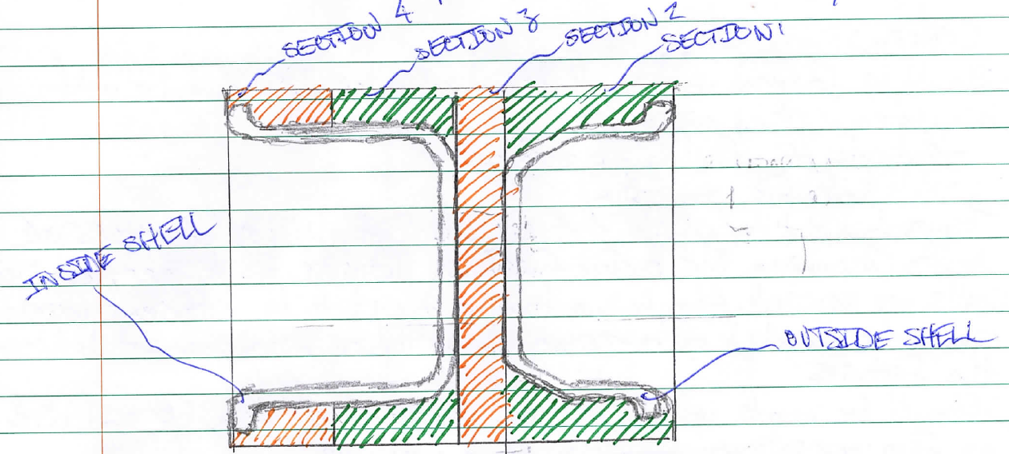

Figure 25: Section View of Mold

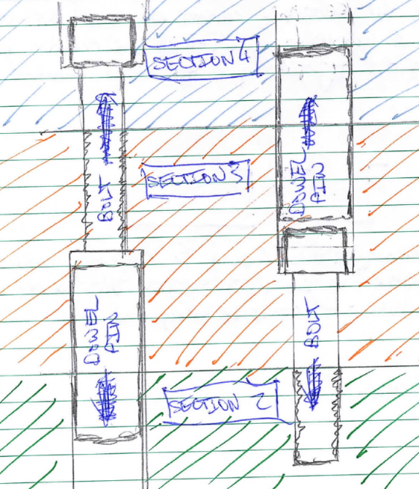

Figure 26: Hand-Drawn Schematic of Dowels

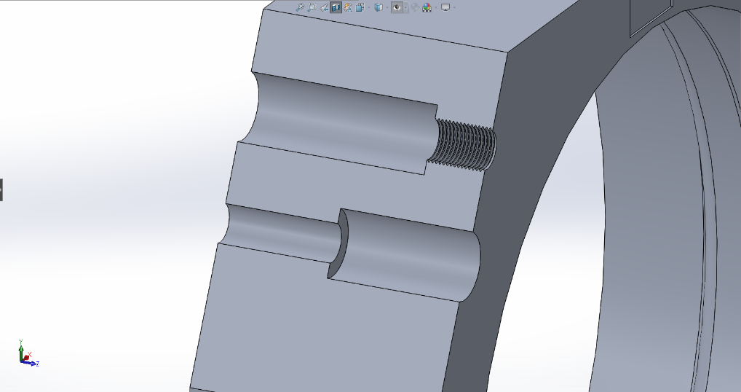

Figure 27: CAD Schematic of Dowels

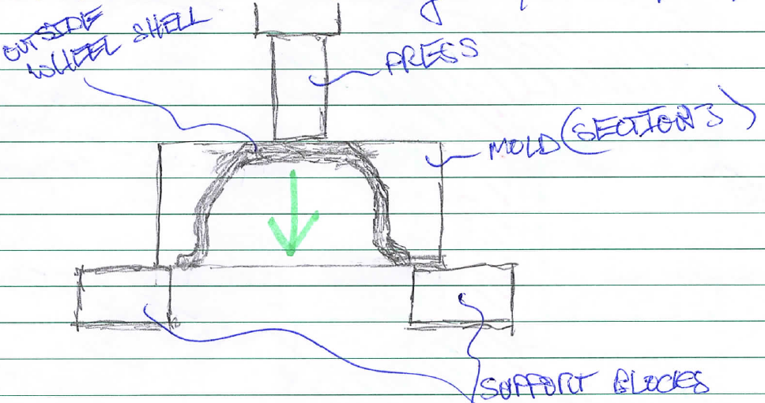

Figure 28: Diagram of Mold Removal Using a Drill Press

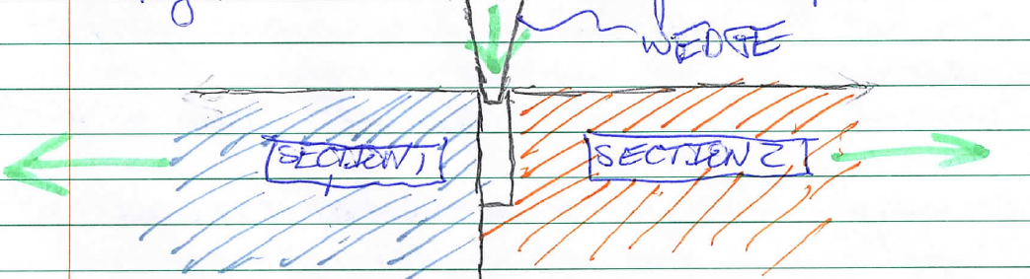

Figure 29: Diagram of Section Separation

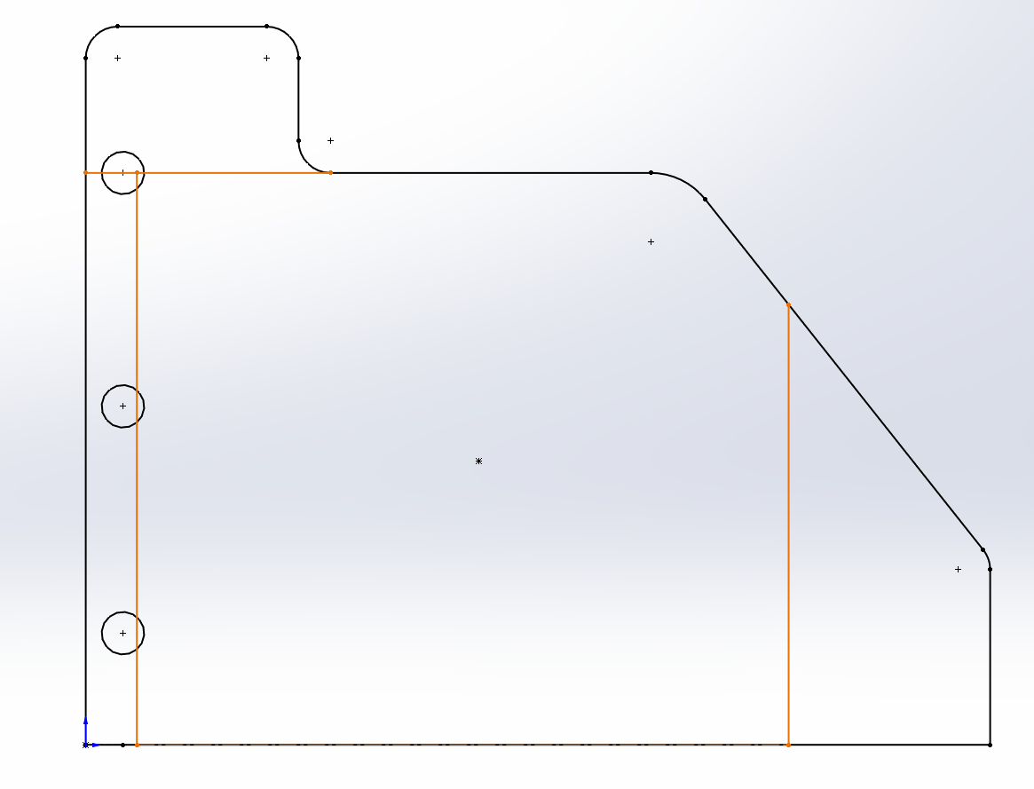

Figure 30: Band Saw Cuts to be made in Aluminum Block

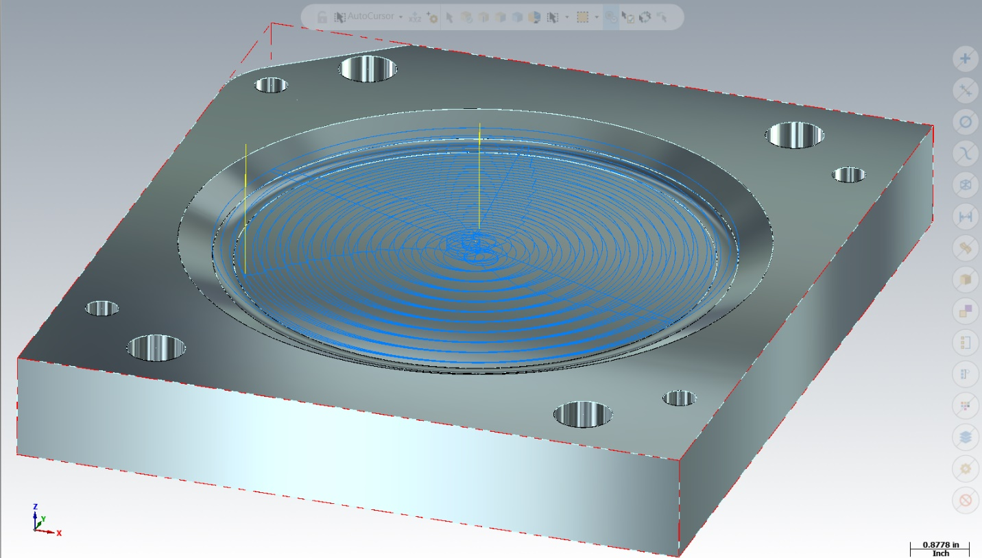

Figure 31: Preliminary Roughing Tool Path for Section 2

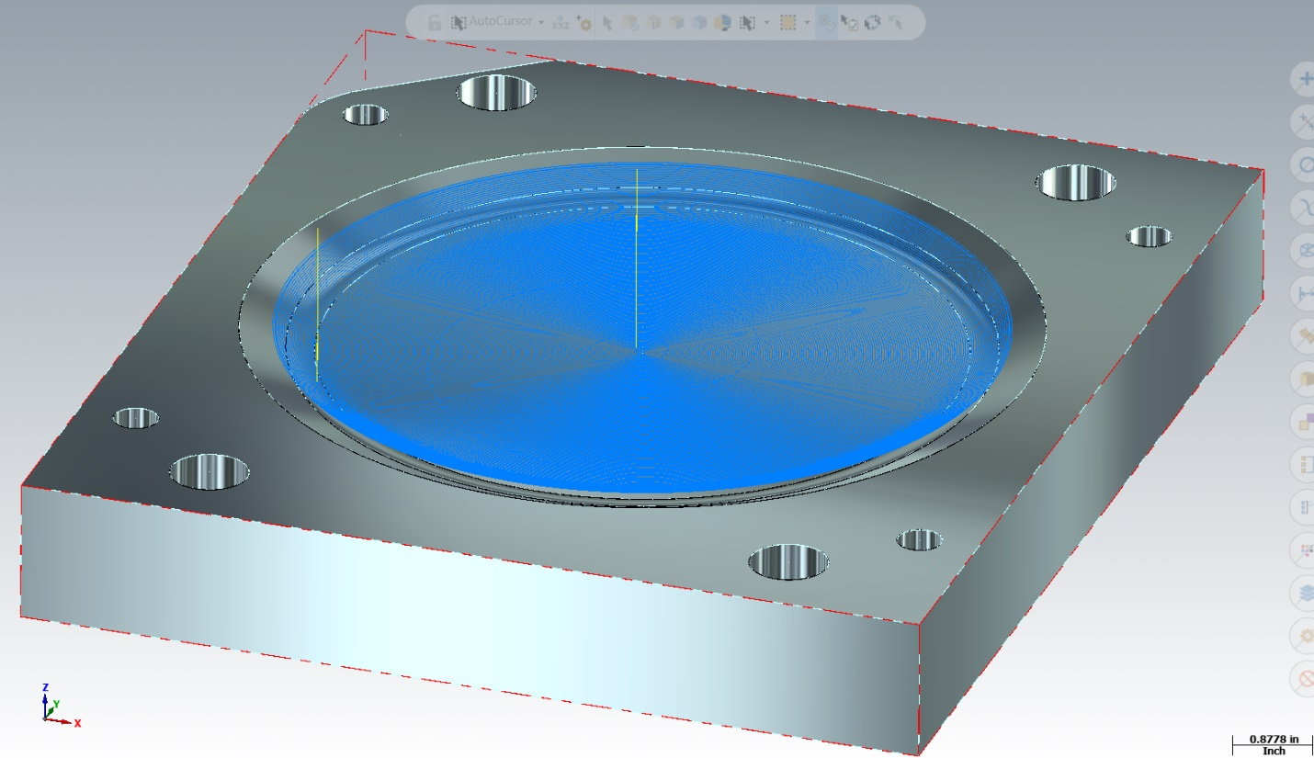

Figure 32: Preliminary Finishing Tool Path for Section 2

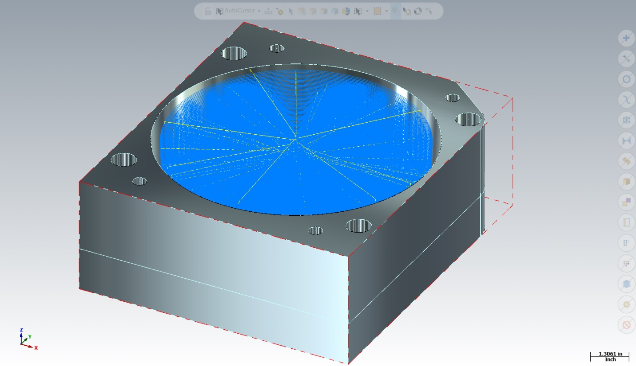

Figure 33: Preliminary Roughing Tool Path for Section 3

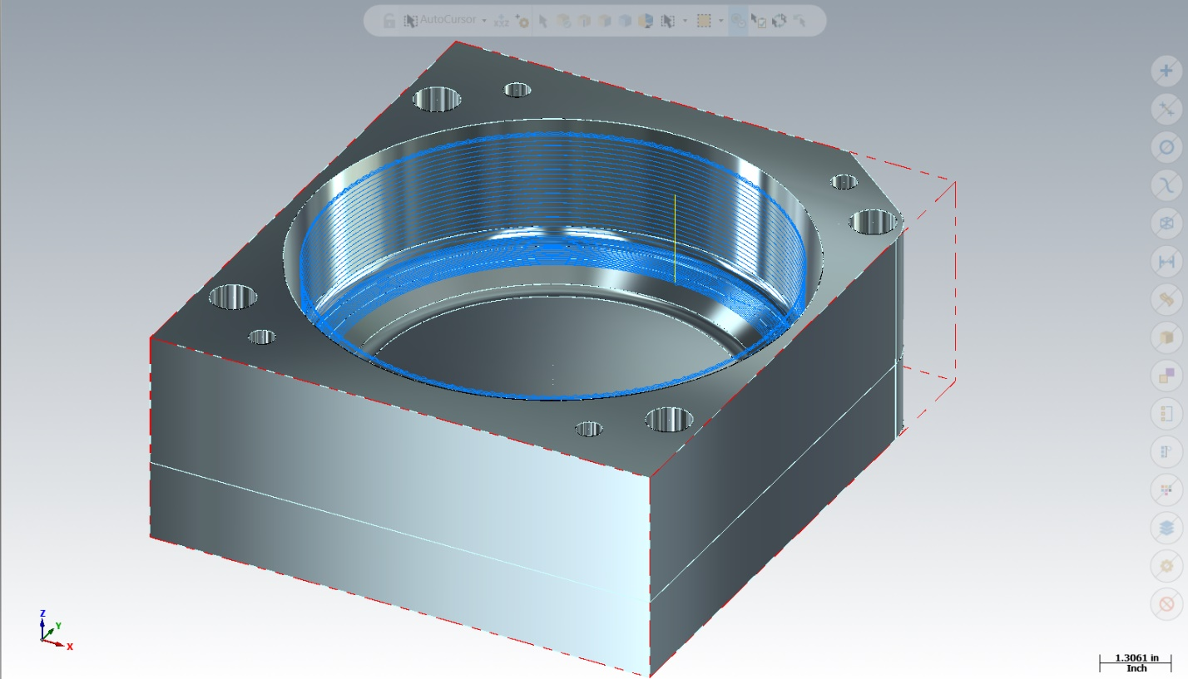

Figure 34: Preliminary Finishing Tool Path for Section 3

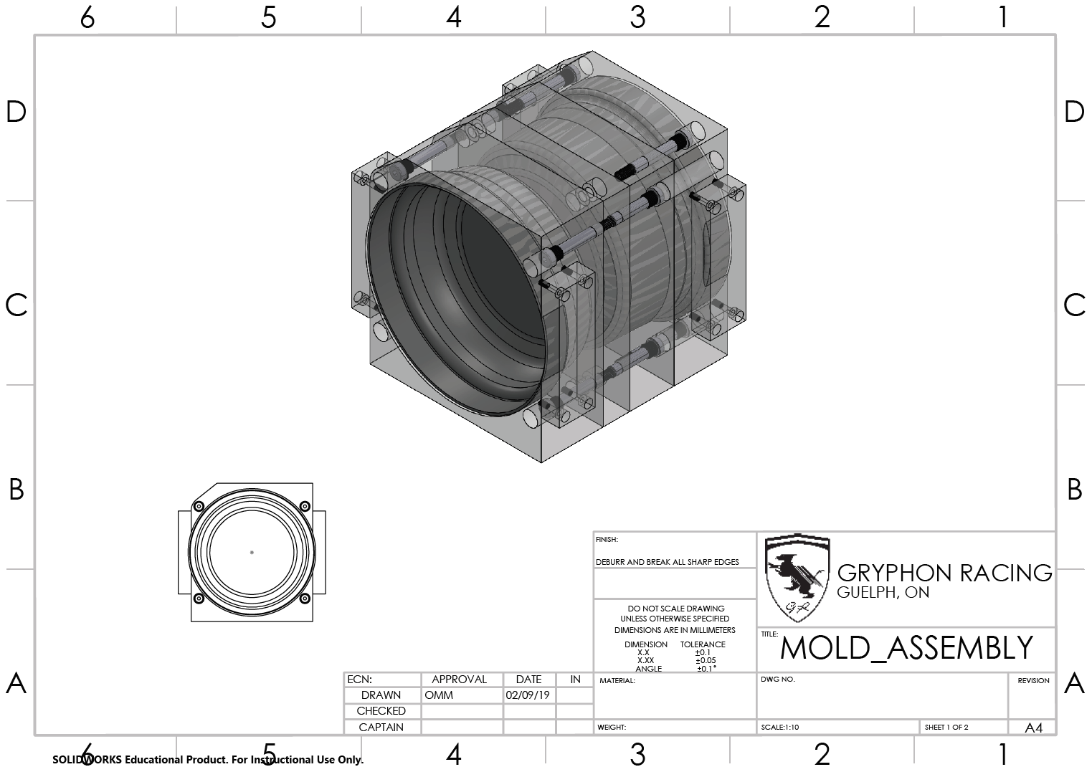

Figure 35: Fully Assembled Mold in 3D

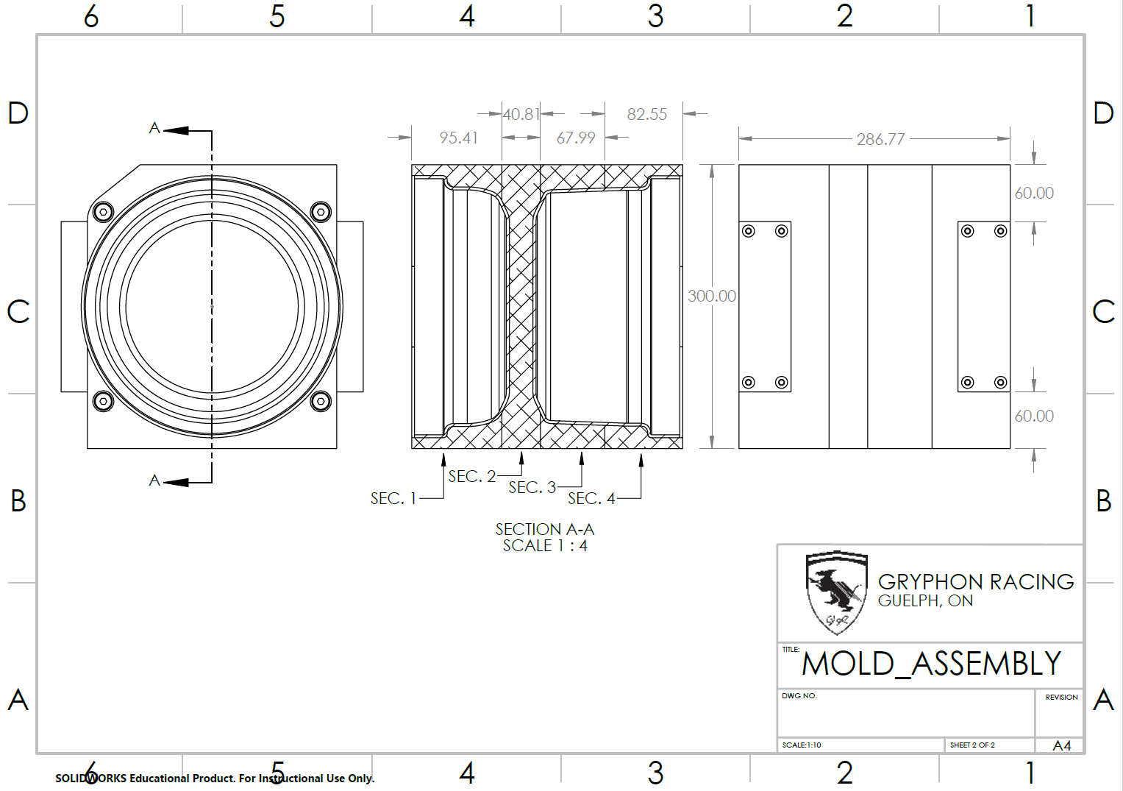

Figure 36: Fully Assembly Mold in 2D

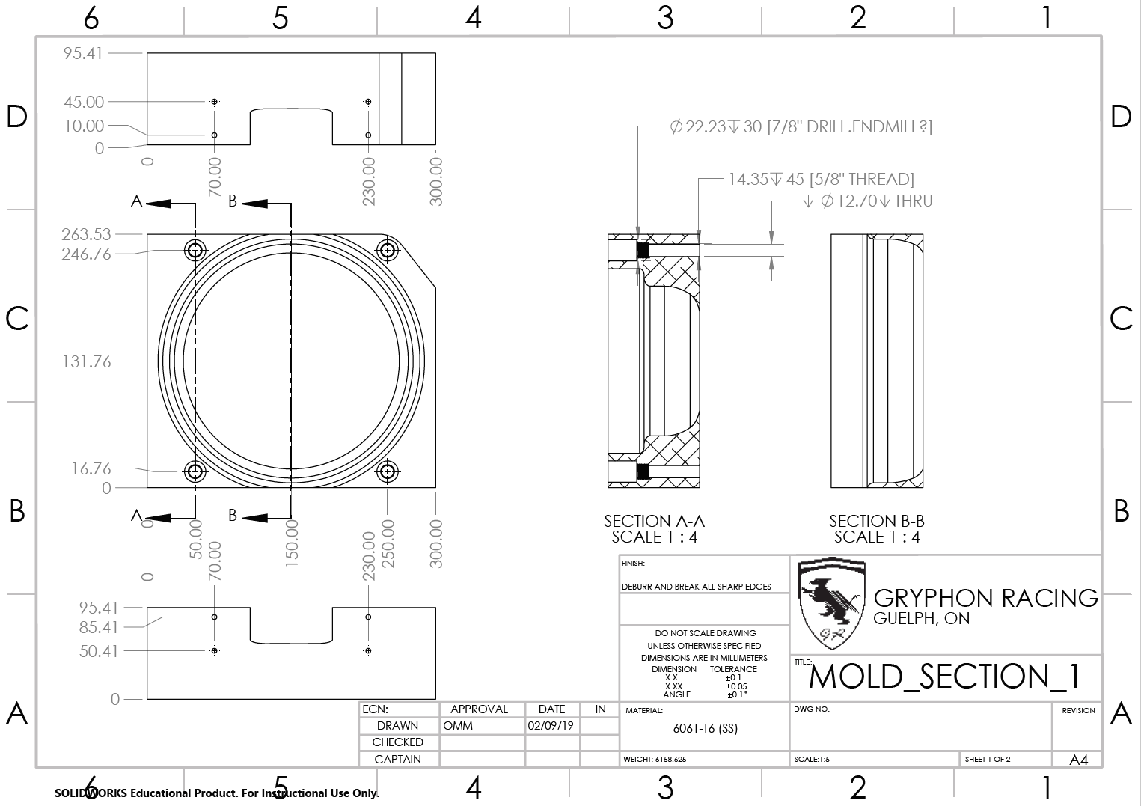

Figure 37: Schematic of Mold Section 1

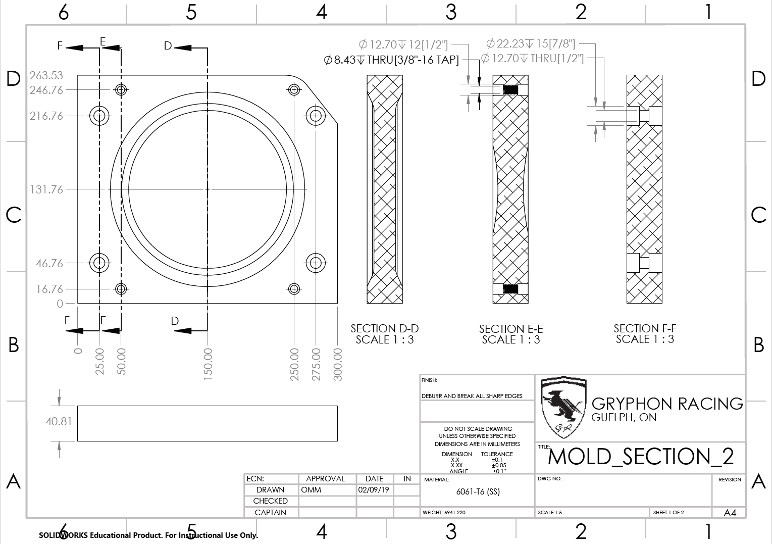

Figure 38: Schematic of Mold Section 2

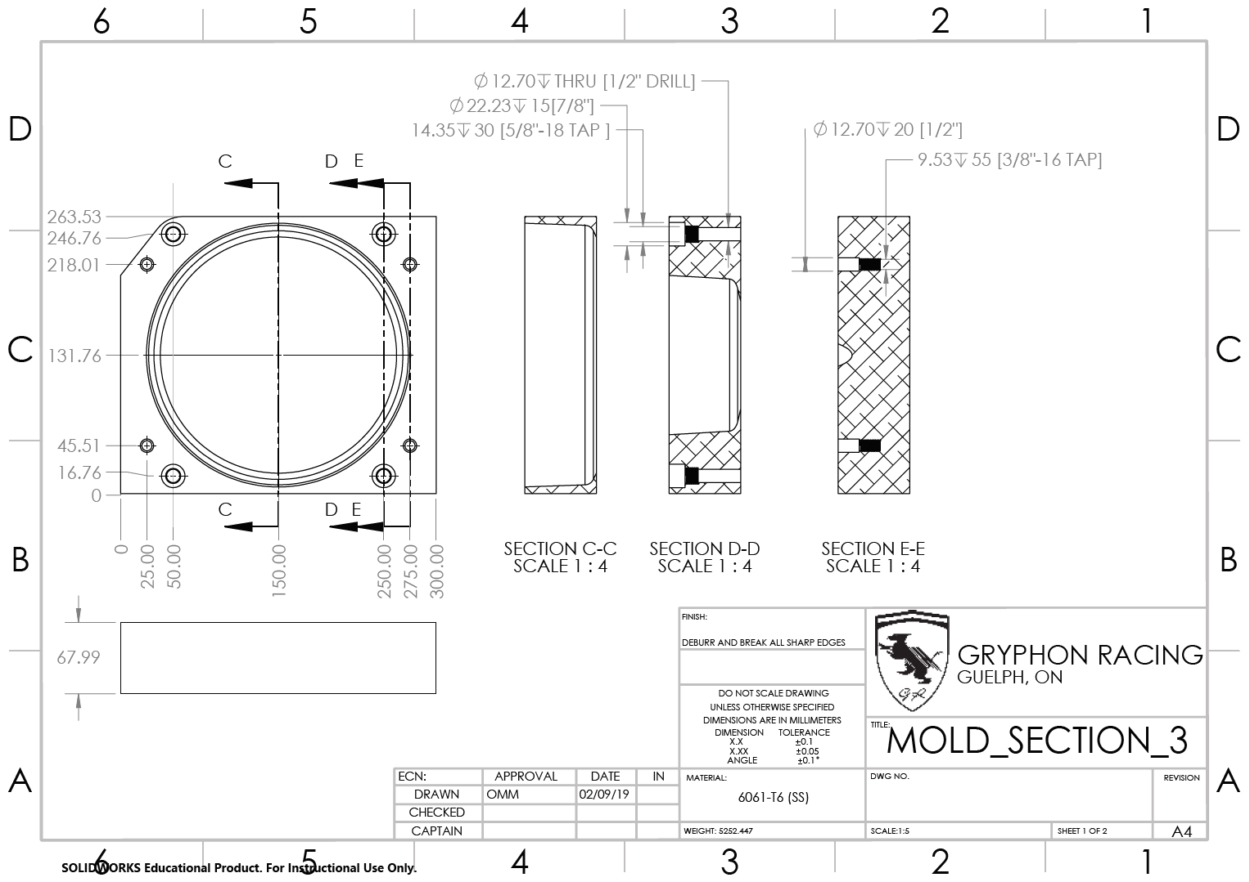

Figure 39: Schematic of Mold Section 3

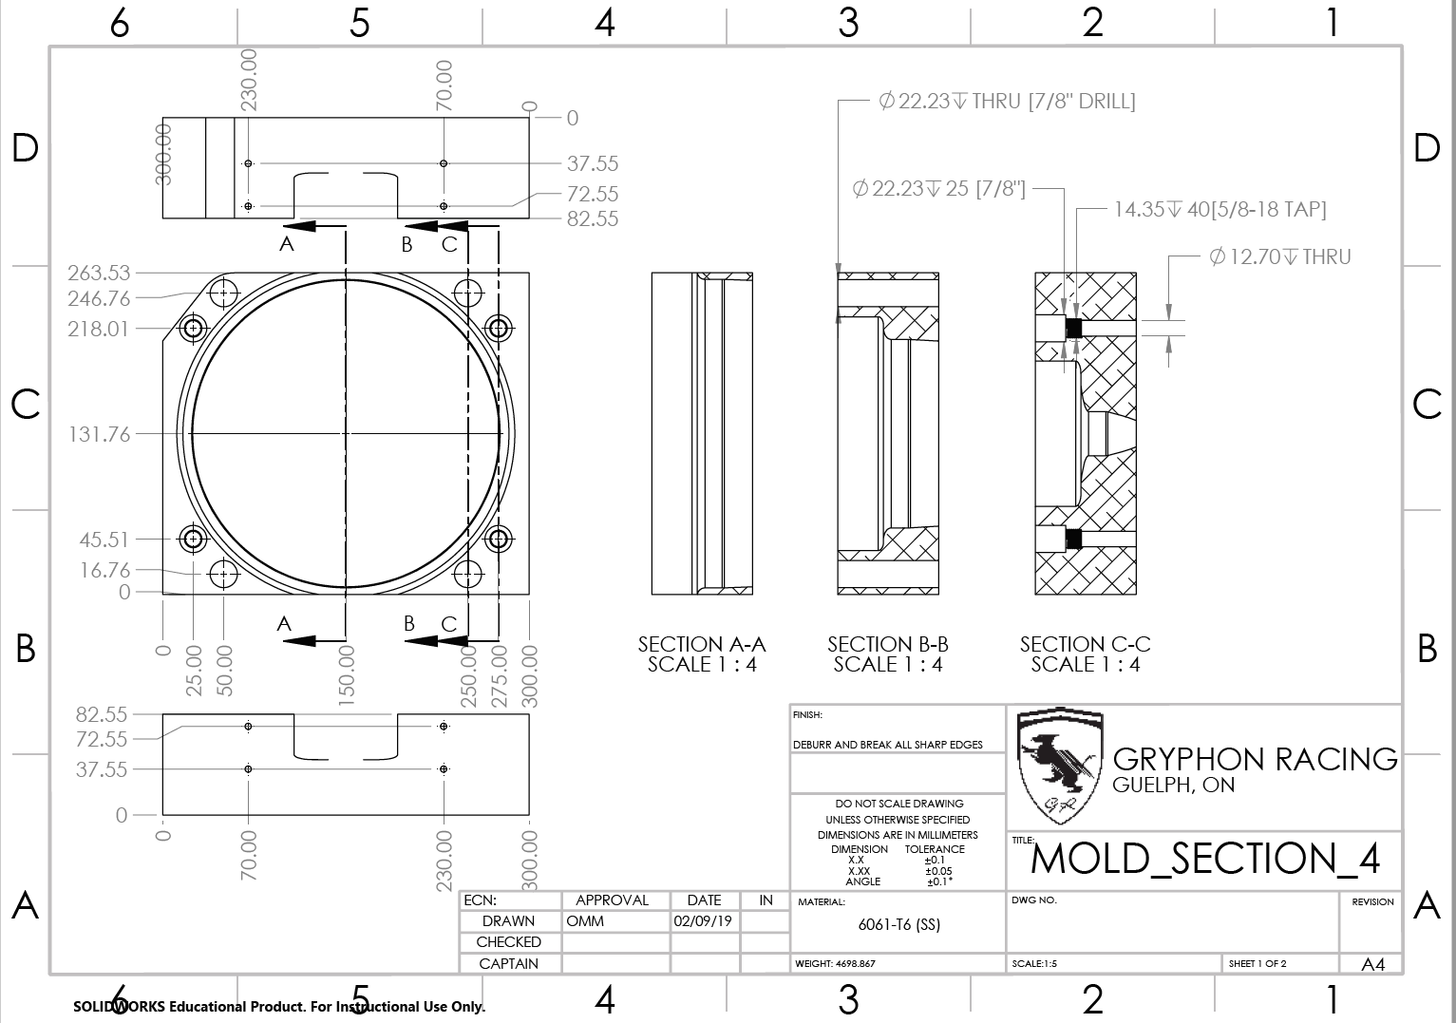

Figure 40: Schematic of Mold Section 4

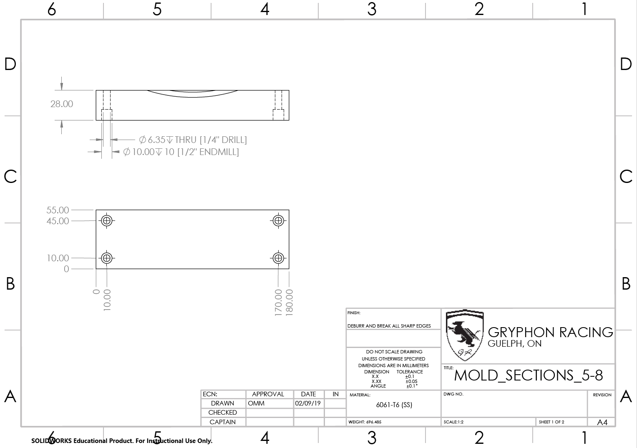

Figure 41: Schematic of Side Handles

# Bill of Materials and Equipment

|  |  |  |  |  |
| --- | --- | --- | --- | --- |
| **Mold** | | | | |
| Description | Quantity | Supplier | Part # | Notes |
| 1/2" Socket Head Shoulder Bolts | 8 | Fastenal | 26358 | 3" shoulder length, 3/8"-16 thread. Used for fastening main mold sections. |
| 1/2" Socket Head Shoulder Bolts | 4 | Fastenal | 26356 | 2.5" shoulder length, 3/8"-16 thread. Used for fastening main mold sections. |
| 1/4" Socket Head Bolts | 16 | Fastenal | 11587951 | 1" length, 1/4"-20 thread. Used for fastening sections 5-8 onto main sections. |
| Aluminum Block: 300x265x100 | 1 | Gryphon Racing | N/A | Section 1. Outside shell of the rim. 6061-T6 Aluminum. |
| Aluminum Block: 300x265x45 | 1 | Gryphon Racing | N/A | Section 2. Bottom face of both outside and inside of rim. 6061-T6 Aluminum. |
| Aluminum Block: 300x265x70 | 1 | Gryphon Racing | N/A | Section 3. Mold 1 of 2 for outside shell. 6061-T6 Aluminum. |
| Aluminum Block: 300x265x85 | 1 | Gryphon Racing | N/A | Section 4. Mold 2 of 2 for outside shell, includes Bead. 6061-T6 Aluminum. |
| Aluminum Block: 180x55x30 | 4 | Gryphon Racing | N/A | Section 5-8. Added mold to provide easy handling and accommodation of wider rims around tire beads. 6061-T6 Aluminum. |
|  | | | | |
| **Rim** | | | | |
| Description | Quantity (each rim) | Supplier | Part # | Notes |
| Aeropoxy PR 2032 Resin and PH 3663 Hardener | 0.22 kg | Canada Composites | AE2032-63-X | High performance epoxy laminating resin used for demanding structural applications |
| 2x2 Twill Weave Carbon Fibre | 0.23 kg | Gryphon Racing | N/A | Carbon fibre with a 2x2 weave, adding flexibility to accommodate a wider range of geometries. |
|  | | | | |
| **Equipment** | | | | |
| Description | Quantity | Location | Part # | Notes |
| Bandsaw | 1 | University of Guelph Machine Shop | N/A | For rough shaping of aluminum blocks. |
| Manual Mill | 1 | University of Guelph Machine Shop | N/A | For the majority of manual work done on molds |
| Water Jet Cutting | 1 | Third-Party shop yet to be determined | N/A | To remove bulk material from molds quickly |
| CNC Machine | 1 | University of Guelph Machine Shop | N/A | For work that is too precise or time-consuming for manual machining |
| Manual Lathe | 1 | University of Guelph Machine Shop | N/A | Machining of mold release bolts |
| Vacuum Pump | 1 | Gryphon Racing Shop | N/A | Maintains vacuum during carbon fibre setting |
| CNC router | 1 | Gryphon Racing Shop | N/A | For machining molded carbon fibre parts |